CENTER FOR HEALTH INFORMATON AND ANALYSIS

ELECTRONIC HEALTH
RECORD DATASET (EHRD)
FILE ENCRYPTION AND
SUBMISSION INSTRUCTIONS

February 2024

Table of Contents

Introduction 3
Summary of Process: 3
Detailed Instructions for Each Step of the Process 3
Appendix 1: Install CHIA Basic FileSecure Application 5
Prerequisites 5
Appendix 2: Encrypt Submission File(s) using Basic FileSecure 8
Appendix 3: Upload Encrypted Submission File(s) to CHIA 12
Appendix 4: Retrieve Edit Detail Report from CHIA’s Submissions Intake Application 15
Appendix 5: Decrypt Edit Detail Report 17

Introduction
Welcome! The purpose of this guide is to provide instructions for securely transmitting Electronic Health Record Dataset (EHRD) Data files to the Massachusetts Center for Health Information and Analysis (CHIA). These instructions supplement the specifications for the format of the submission file and the required data elements within it as identified in the EHRD File Submission Guide. Please review the steps below for submitting files to CHIA.

Summary of Process:
The steps* for securely transmitting submission files to CHIA are as follows:
Step 1: Create Submission File(s) using Provider’s Data.
Step 2: Encrypt Submission File(s) using Basic FileSecure.
Step 3: Upload Encrypted File(s) to CHIA’s Submissions Intake Application.
Step 4: Retrieve Edit Detail Report(s) from CHIA’s Submissions Intake Application.
Step 5: Decrypt Edit Detail Report(s) using Basic FileSecure.
Step 6: Review Edit Detail Report(s) and Resubmit File(s) to CHIA’s Submissions Intake Application (if necessary).
*Detailed instructions for each of the above steps are provided below.
Please contact CHIA at DL-Data-Submitter-HelpDesk@chiamass.gov or your assigned Liaison with any questions or concerns about the process.

Detailed Instructions for Each Step of the Process

Step 1: Create Submission File(s) using Provider’s Data
- Create submission file(s) according to CHIA’s required format outlined in the EHRD File Submission Guide available on CHIA’s website in the blue Report Resources box at this link

  - Text files need to have the file extension “.txt” in lowercase in order to encrypt successfully.

Step 2: Encrypt Submission File(s) using Basic FileSecure
- Since CHIA requires that providers encrypt each submission file before transmission, CHIA provides an application for encrypting and decrypting files at the provider site. Initially, each provider should download and install the application called Basic FileSecure according to the instructions in Appendix 1: Install CHIA Basic FileSecure Application. Before installing updated versions, please remove older versions of Basic FileSecure from your computer by deleting the following folder: C:\Program Files (x86)\CHIA Basic FileSecure.
- After successfully downloading and installing the Basic FileSecure application, the submission file(s) created in Step 1(above) should be encrypted using the instructions in Appendix 2: Encrypt Submission File(s) using Basic FileSecure.
- The Basic FileSecure application is also used to decrypt the Edit Detail Reports created by CHIA (see Step 5.)

Step 3: Upload Encrypted File(s) to CHIA’s Submissions Intake Application
- Once the submission file is created and encrypted, it should be uploaded to CHIA according to the instructions in Appendix 3: Upload Encrypted Submission File(s) to CHIA.

Step 4: Retrieve Edit-Detail Report(s) from CHIA’s Submissions Intake Application
- CHIA processes each submission by applying edits to the overall file format and applying edits to the data elements submitted. This process creates a report called the Edit Detail Report which includes any errors triggered by editing the submitted data. Each provider can retrieve an encrypted copy of the Edit Detail Report from the CHIA Submissions Intake application by following the instructions in Appendix 4: Retrieve Edit Detail Report from CHIA’s Submissions Intake Application.

Step 5: Decrypt Edit Detail Report(s) using Basic FileSecure
- Before each provider opens the Edit Detail Report, he/she should decrypt the report to transform the file format from an encrypted file to an EXCEL spreadsheet with multiple tabs. The instructions for decrypting the report are in Appendix 5: Decrypt Edit Detail Report using Basic FileSecure.

Step 6: Review Edit Detail Report(s) and Resubmit File(s) to CHIA’s Submissions Intake Application (if necessary)
- If the submission file(s) require updates and/or corrections based on the review of the Edit Detail Report(s), the provider should update the file(s) and resubmit according to the instructions in Steps 1-3 above. Please contact CHIA at DL-Data-Submitter-HelpDesk@chiamass.gov with any questions or concerns about the report(s) or the submission process.

Appendix 1: Install CHIA Basic FileSecure Application

Prerequisites
- Downloading the executable file may require Administrator access to complete the Basic FileSecure installation. Please check with your organization’s internal PC or network administrator contacts.
- Basic FileSecure has been tested and certified to run under:
- Windows 10 & 11 64 Bit (Note: FileSecure will NOT run under Windows XP).

- The Basic FileSecure application is encoded with an encryption key that is unique to your hospital(s), so it is important that you remove any older references to FileSecure (if present) prior to your file download. Older versions of Basic FileSecure can be removed by deleting the following folder: C:\Program Files (x86)\CHIA FileSecure.
- When using Google Chrome, be sure to clear all Google cache and cookies in your browser so that previous versions of Basic FileSecure have been removed entirely.

.

Step 1: Log into CHIA Submissions
Log into CHIA Submissions* using Google Chrome with the username and password you received from CHIA.
Website URL: https://chiasubmissions.chia.state.ma.us
*Login issues can be addressed by contacting DL-Data-Submitter-HelpDesk@chiamass.gov.
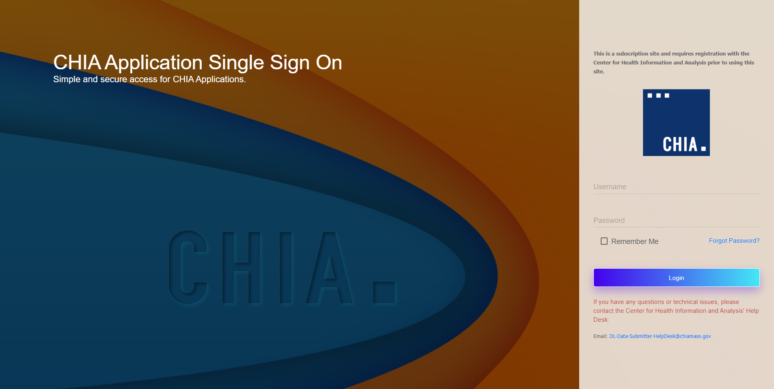

Step 2: Download Basic FileSecure
- Once logged into CHIA Submissions, please download the Basic FileSecure application by clicking the Launch button in the Basic FileSecure folder. After installing Basic FileSecure on your workstation (or local resource of your choice), you will use the utility to encrypt EHRD files for submission.
Note: If other filings are submitted to CHIA for different purposes, they may also appear on this landing page.
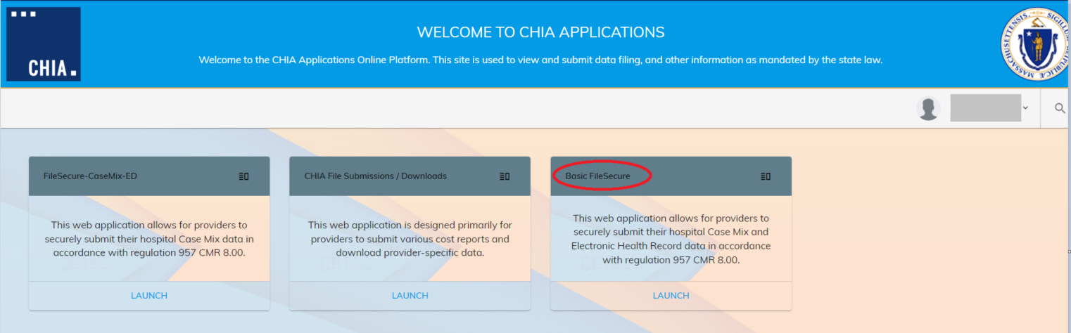
- Upon selection of the icon button, CHIA is dynamically creating a custom Basic FileSecure for your organization. Once the page appears click the Download >> button.
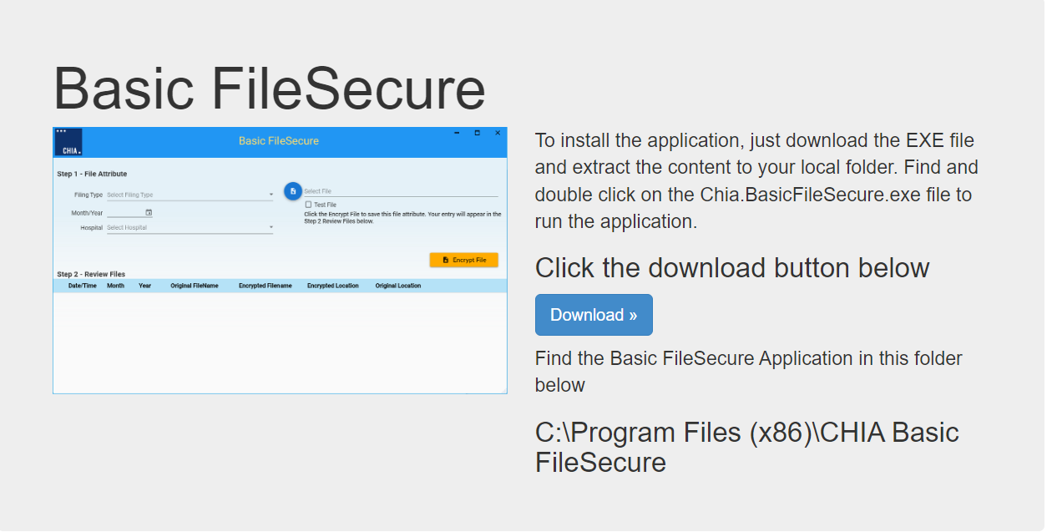
- The install program will be downloaded to the Downloads folder (e.g. C:\Users\”janedoe”\Downloads) by default.
- When the download is complete, you will see the install file named Basic FileSecure.exe in your downloads folder.
- Double click on the Basic FileSecure.exe file.

- Depending on your virus software, you may receive a message similar to the following. Click “Allow this file”.

- You will receive the following pop-up. Click “Yes” to install.
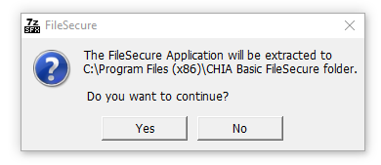
- If you receive the below error message, you do not have the access rights on your PC or workstation to install the Basic FileSecure application. Click on the “OK” button.
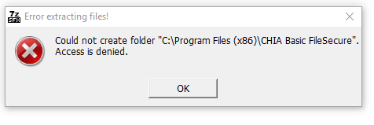
- To fix this you will need a network or system administrator to install Basic FileSecure. Once the administrator installs FileSecure, the administrator needs to give you Read and Write permissions to the following folder: C:\Program Files (x86)\CHIA Basic FileSecure.

Appendix 2: Encrypt Submission File(s) using Basic FileSecure

Step 1: Open FileSecure and Adjust Settings
- Basic FileSecure can be launched by clicking on the shortcut on the desktop or the CHIA Basic FileSecure executable (.exe.). The executable file is located where the application was saved (typically saved to the Program Files x86 folder in your C: drive or personal desktop.) See the folder path and highlighted file in the image below. Click on the highlighted executable to launch Basic FileSecure.
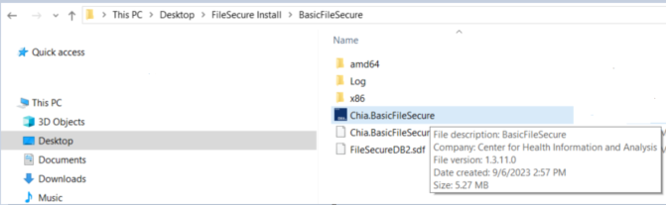

Encrypt File Submission Initial Page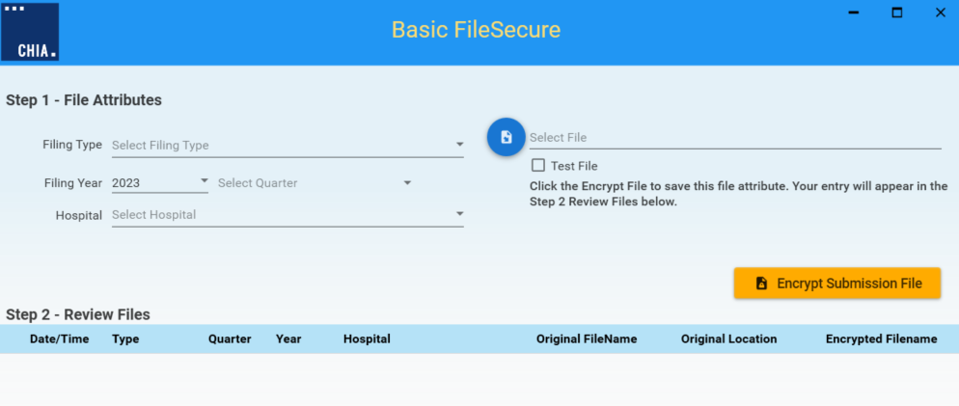
- Before proceeding with entries on the Encrypt Submission File page, you will need to designate where encrypted files will be stored on your computer or internal network. Using the Menu dropdown from the CHIA logo, please select Settings. If you do not select a file location, the Filing Home page will redirect you to the Settings page.
- Click on the blue CHIA box at the top left side of the screen.

- Select the Settings item from the drop-down menu.
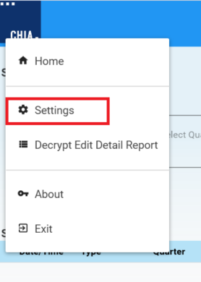
- Once at Settings, click on the folder icon to the right of Encrypted File Folder. Browse your Windows File Explorer and designate a file location where newly encrypted files can be stored and retrieved later. You may create a new folder by clicking on Make New Folder in the Browse for Folder pop-up. Once a designated location is selected, click on the orange Save button at the top right side of the screen.
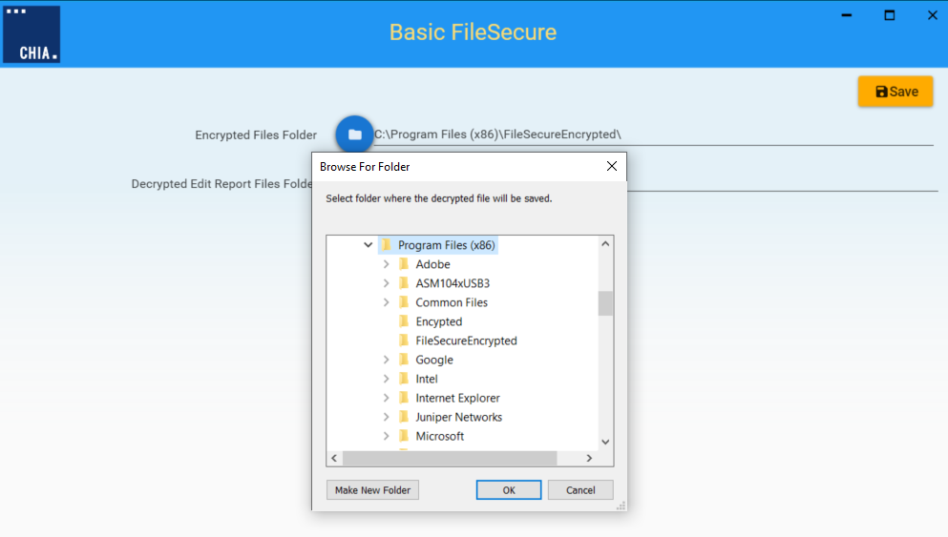

Step 2: Encrypt File(s)
- If you are not on the Basic FileSecure Home page, click on the blue CHIA box at the top left side of the screen. Click on Home in the drop-down menu.
- Populate all entries on the left side of screen in Step 1 – File Attributes. You must provide Filing Type (Electronic Health Record Data [EHRD]), Filing Year (Fiscal Year), Select Quarter (Fiscal Quarter) and Hospital.
- Click on the blue icon on the left of Select File. Search for and attach the file to be encrypted. Click on the orange Encrypt Submission File button.
- Test Files: Check the Test File box if you intend for the file to be uploaded to CHIA’s Test database. If unchecked, the submitted files will be uploaded to the Production database and will be processed as a valid submission for the Filing Year and Quarter entered.
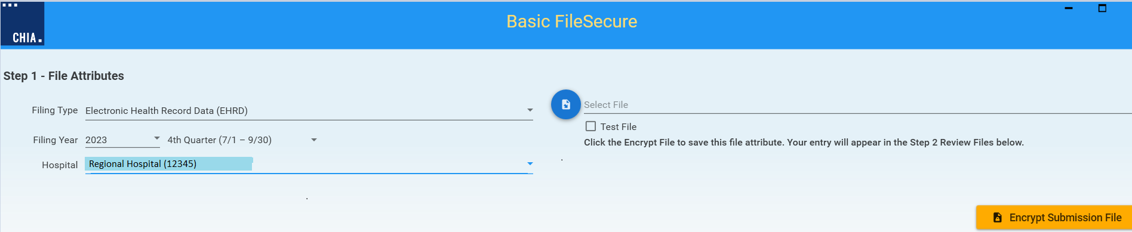

e) Basic FileSecure Common Error Messages: Below is a table that provides explanation for the most common errors that a submitter may encounter when encrypting a file using Basic FileSecure. If you are experiencing any issues with encrypting your file, please contact CHIA at DL-Data-Submitter-HelpDesk@chiamass.gov or reach out to your assigned CHIA liaison.
Basic FileSecure Error Messages: | Explanation of Error
Invalid File | This message may stem from incorrect formatting within your file. A valid file must have all of the following:  - Must have one header record (Record Type 1)  - Data records (Record Type 2) must have 71 delimiters (asterisks)  - A carriage return must be present at the end of each record, including the last record in the file.  - Submitters must have ‘write’ access to the folder where encrypted file is to be saved.
Error Encrypting File. Could not find a part of path | The encryption folder may have been altered or deleted.
Line number <#> includes invalid number of delimiters | This message includes the line number that encounters the error. Record Type 1 must include 4 delimiters and Record Type 2 must include 71 delimiters.
Line number <#> includes invalid type of delimiter. | This message includes the line number that encounters the error. A record may only include asterisk delimiters to separate data elements, or pipe delimiters to separate data elements with more than one reported value.
The file has been renamed or no longer exists in specified location | The file may have been renamed prior to encryption or the file cannot be located.

Step 3: Review Encrypted File(s)
CHIA has built in a decrypt function which allows the Provider to decrypt encrypted files.
- To decrypt a file, click on the blue Decrypt button. You will be prompted to select a folder location where the decrypted file will be saved.
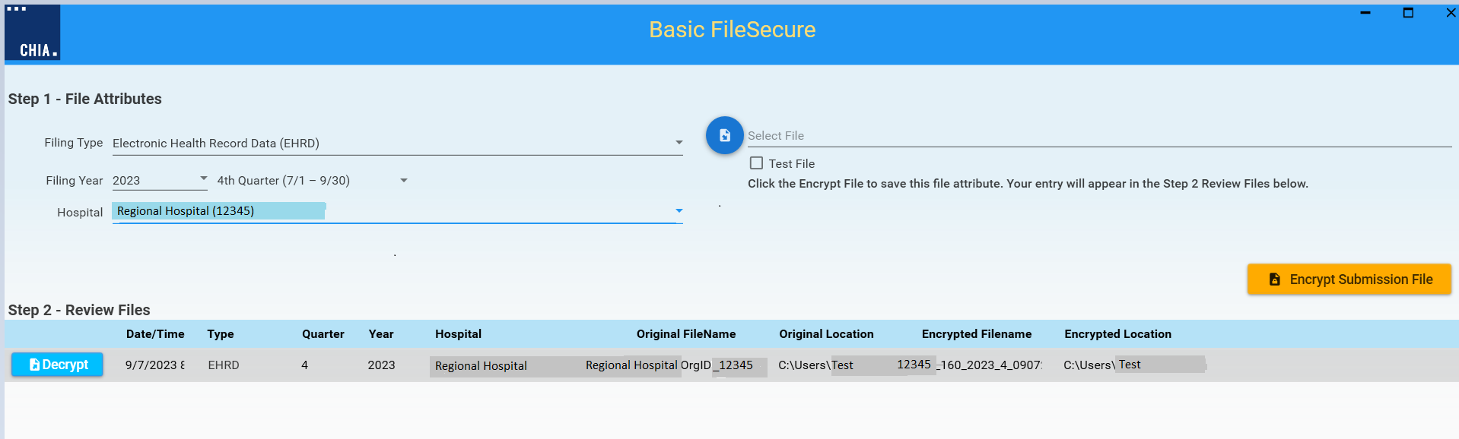
Note: Column headers are adjustable by highlighting the blue divider line and moving the width.

Appendix 3: Upload Encrypted Submission File(s) to CHIA

Step 1: Log into CHIA Submissions Intake Application
Log into CHIA Submissions* with the username and password you received from CHIA using Google Chrome.
Website URL: https://chiasubmissions.chia.state.ma.us
*Login issues can be addressed by contacting DL-Data-Submitter-HelpDesk@chiamass.gov.
- Click on the Launch button in CHIA File Submissions / Downloads folder after successful login.
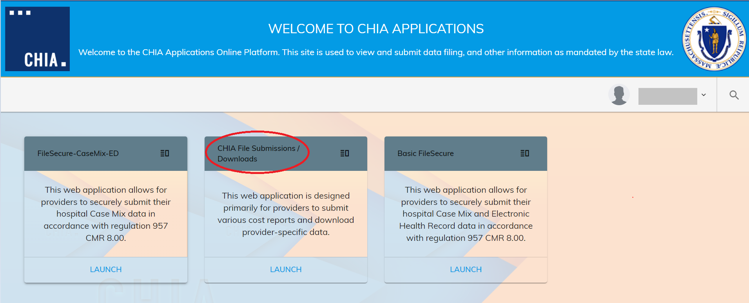
Note: If other filings are submitted to CHIA for different purposes, they may also appear on this landing page.

Step 2: Select Submission Type
- Select Case Mix from the Select Submission Type box and click on the OK button.
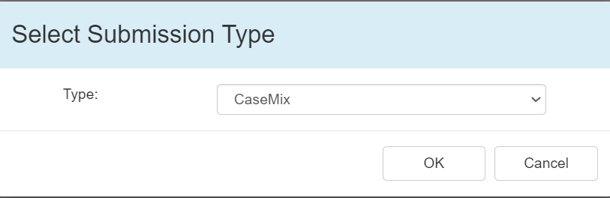

Step 3: Upload.
- Click on the orange Upload a file button, located in the upper right of the screen.

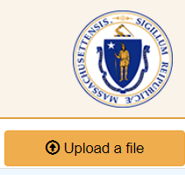

Step 4: Enter required fields.

- All fields in the File Upload pop-up are required.
- Select Electronic Health Record Data (EHRD) from the Submission Type dropdown list. Then provide Hospital Name, Filing Year, and Quarter. Populate Filename by clicking on the Browse button and attaching the file for submission. Then, hit OK to submit the file.
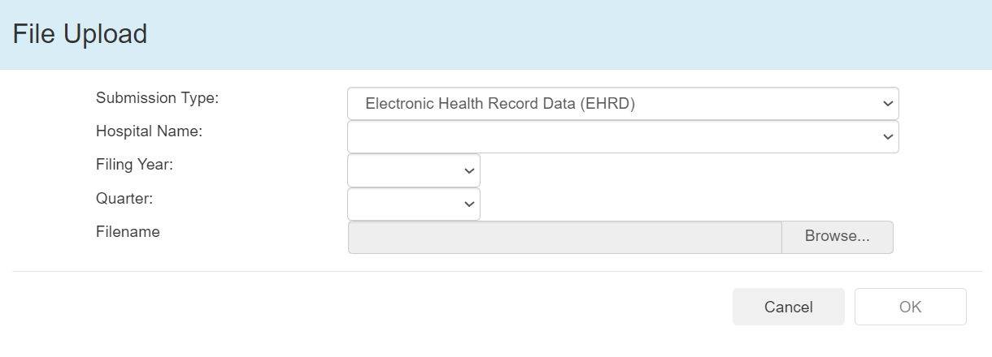
- You will receive the following message when the file is successfully uploaded. Click on the OK button to close the message.
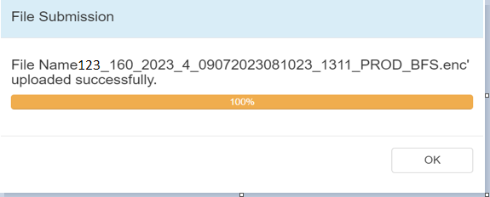

File Upload Details
- Successfully uploaded files will appear on the CHIA File Submissions screen. The following is a sample of some of the submission details. You may use the horizontal scroll bar at the bottom of the screen to scroll and view all columns.
Note: Column headers are adjustable by highlighting the divider line and moving the width.
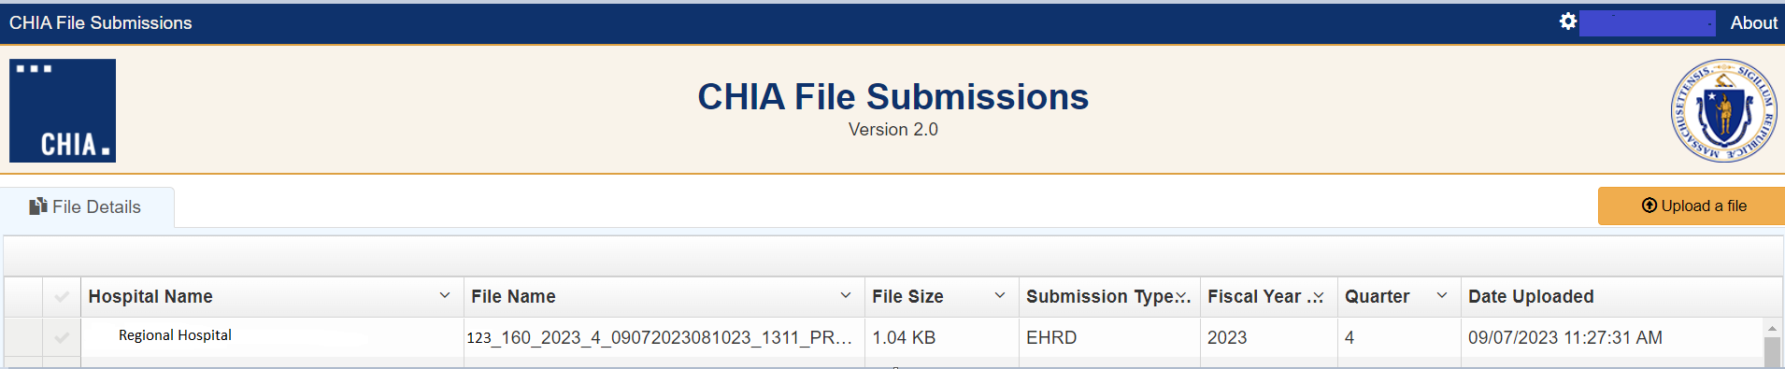

Appendix 4: Retrieve Edit Detail Report from CHIA’s Submissions Intake Application

Step 1: Log into CHIA Submissions Intake Application
Log into CHIA Submissions* with the username and password you received from CHIA.
Website URL: https://chiasubmissions.chia.state.ma.us
*Login issues can be addressed by contacting DL-Data-Submitter-HelpDesk@chiamass.gov.

- Click on the Launch button in CHIA File Submissions / Downloads folder after successful login.
Note: If other filings are submitted to CHIA for different purposes, they may also appear on this landing page.
- Select Case Mix and click on the OK button.

Step 2: Download the Encrypted File
- Scroll to the Edit Detail Report Name column that is displayed on the CHIA File Submissions screen. Click on the green EXCEL icon beside the file name. The file will be downloaded to the user’s Downloads folder OR the user’s designated folder for encrypted files.

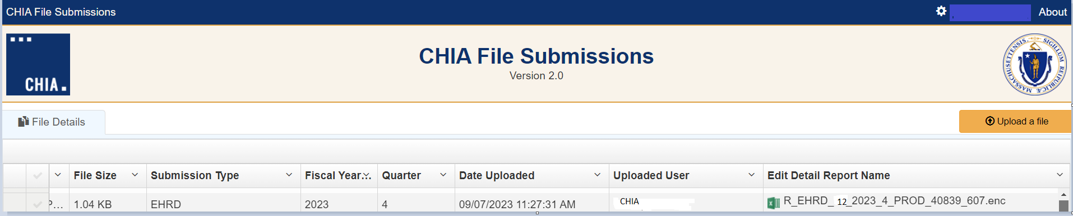

Appendix 5: Decrypt Edit Detail Report

Step 1: Log into Basic FileSecure and Adjust Settings
- Basic FileSecure can be launched by clicking on the shortcut on the desktop or the CHIA Basic FileSecure executable (.exe.) file. The executable file is located where the application was saved (typically saved to the Program Files x86 folder in your C: drive or personal desktop.) See the folder path and highlighted file in the image below. Click on the highlighted executable to launch Basic FileSecure.

- The following screen will display once Basic FileSecure is launched.

Step 2: Decrypt File(s)
- Click on the blue CHIA box at the top left side of the screen.
- Select the Decrypt Edit Detail Report item from the drop-down menu.
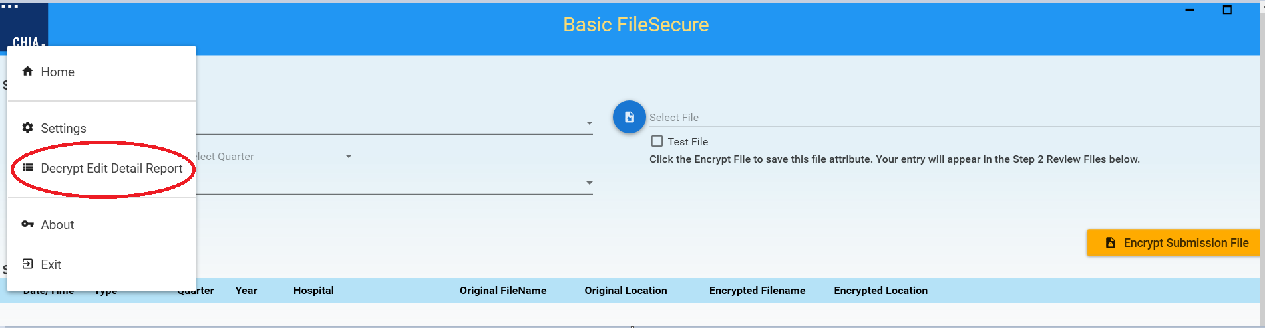
- Click on the icon next to Browse Encrypted (.ENC) File to locate the encrypted Edit Detail Report file. The decrypted file will be stored in the Decrypted Files folder where the application was saved.
- Select Hospital from the dropdown list and click on the orange Decrypt / Save button to decrypt and save the file.
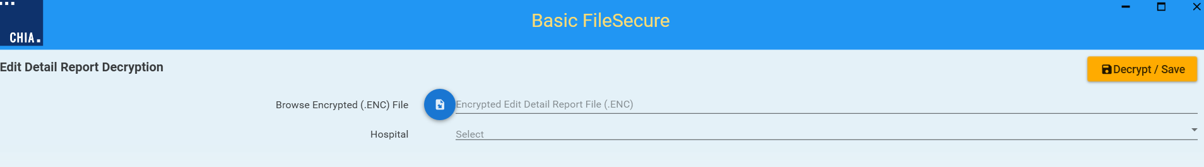
- If a designated location was not created, you will receive the following message:
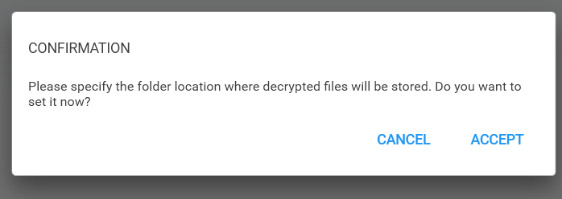
- Click on the Accept button to designate a location for decrypted files.
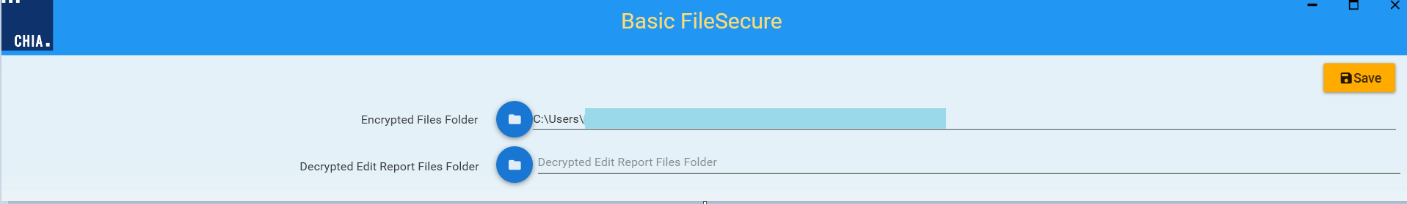
- Click on the folder icon next to Decrypted Edit Report Files Folder.
- You may either select an existing folder, or you may create a new folder by clicking on the Make New Folder button. Click on the orange Save button at the top right side of screen. The decrypted file will be stored in the designated folder.
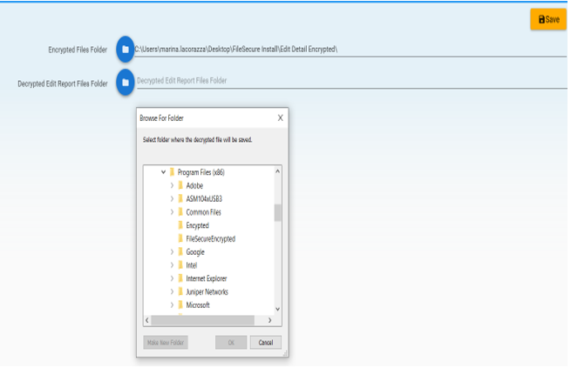
08
Fall

