CENTER FOR HEALTH INFORMATION AND ANALYSIS

CHIA SUBMISSIONS USER GUIDE: TOTAL MEDICAL EXPENSES AND ALTERNATIVE

PAYMENT METHODS

A u g u s t 2 0 2 3

SUBMITTING THE EXCEL FILE

Total Medical Expenses and Alternative Payment Methods: CHIA Submissions
- Access CHIA’s online submission platform at https://chiasubmissions.chia.state.ma.us. Then log-in with a valid username and password. The credentials will be the same as the ones used prior for INET submissions.
  - If you are new user for a payer that is registered with CHIA, please complete a User Agreement and email the completed form to DL-Data-Submitter-HelpDesk@chiamass.gov. For technical issues, please email DL-Data-Submitter- HelpDesk@chiamass.gov.
  - If you are a new user for a new payer that is not registered with CHIA you must also submit a Business Partner Security Form to CHIA in order to submit TMEAPM through CHIA Submissions
Please Note: CHIA Submissions works best with Google Chrome.

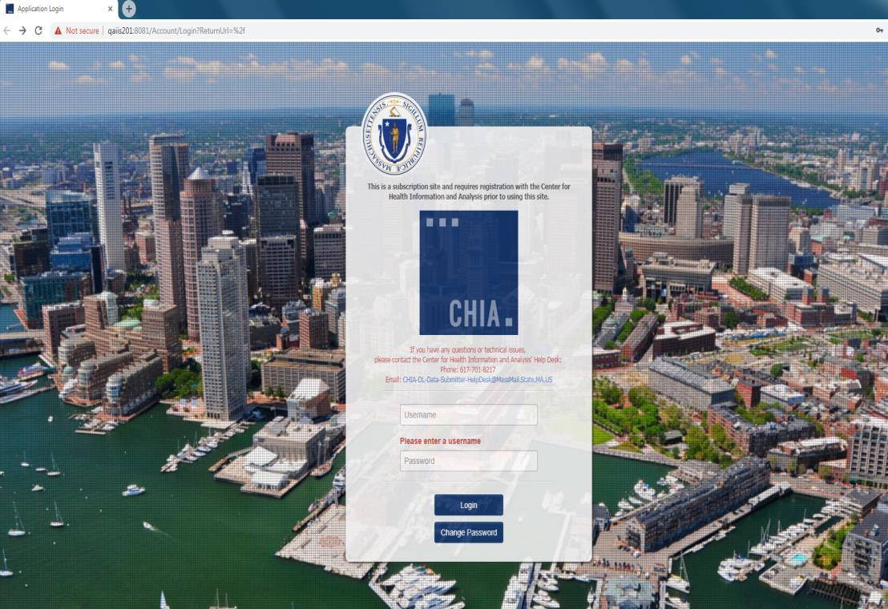

- Successful access brings you to the Main Menu page. Choose the selection box titled ‘CHIA File Submissions’.

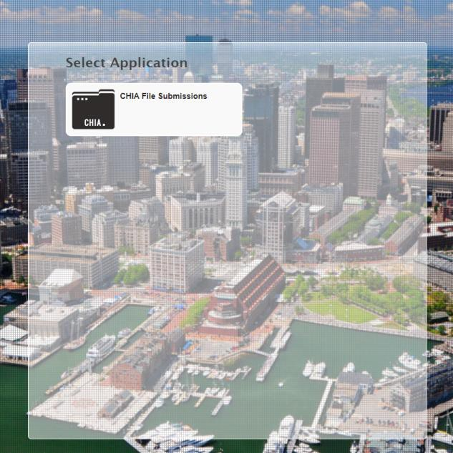

- You will see “TMEAPM Submissions” next to File Details on the left hand side. Your organization name will be displayed at the top right, above the Save and Upload button.
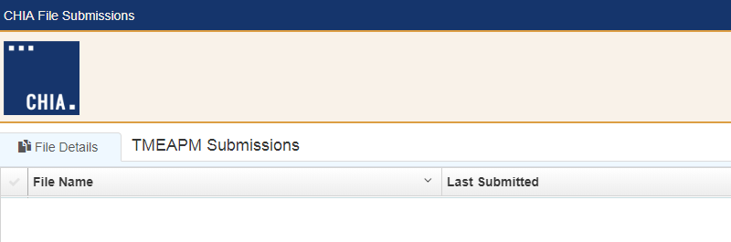
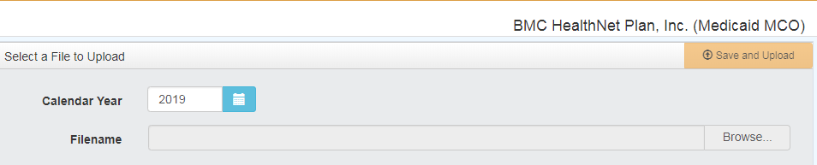

TME-APM File Selection and Upload

- Choose the correct ‘Submission Year’ via the available dropdown boxes on the right.
- Once selected, hit the ‘Browse’ button to choose the final file that you have saved from your own computer workstation.

- Browse your File Manager or your Windows Explorer on your computer workstation and select the file saved using the “Save Submission File” button. Apply the file to CHIA Submissions by using the ‘Open’ key in the lower right corner of the screen. Your file name will appear in the Filename line. The file must be saved with the appropriate CHIA Naming Convention generated using the “Save and Name” button on the front page of the Excel template.
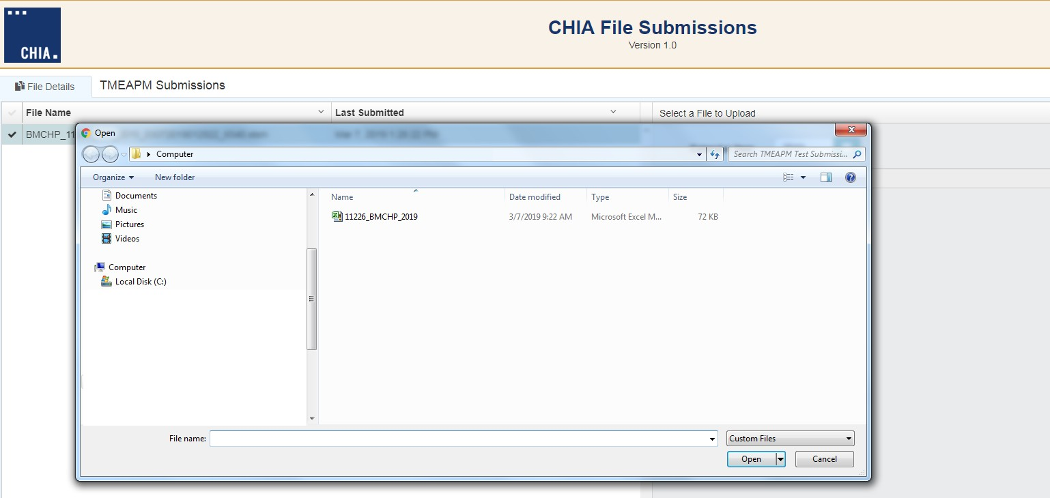

- To upload the File, to the CHIA Submissions application, hit the Save and Upload button.

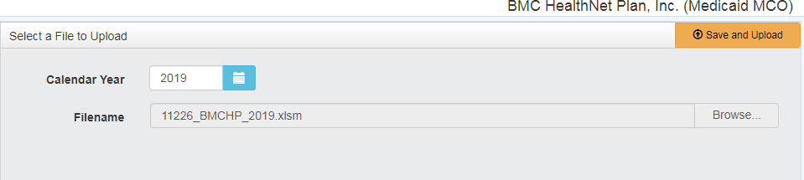

- When the progress bar shows 100%, you will see your Filename is uploaded successfully.
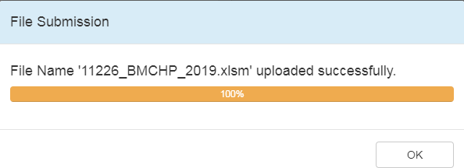

FREQUENTLY ASKED QUESTIONS (FAQ)

Who can access the web application?
Users who are registered with CHIA to submit the Total Medical Expenses (TME) and Alternative Payment Methods (APM) filing will be able to access the application located at https://chiasubmissions.chia.state.ma.us. For additional users and technical issues, please email DL-Data-Submitter-HelpDesk@chiamass.gov.

What are my system requirements?
The Microsoft (MS) Excel template is fully supported with MS Excel 2010 or higher. CHIA Submissions is fully supported on Google Chrome.

How can I request to add new user(s)?
Payers needing to change users or request additional users should complete a User Agreement and email the completed form to DL-Data-Submitter-HelpDesk@chiamass.gov.

Can one payer have multiple submitters?
User access can be granted for multiple individuals.

How do I update information in a submitted report?
If a payer needs to update information in an already submitted report, users should email Molly.Bailey@chiamass.gov to inform CHIA of the intent to resubmit and provide good cause for resubmission.

What are the different types of errors and how do I avoid them?
  - Use the “Save and Name” button on tab “A. Front Page” to save your file after review, do not try to save the file in any other way
  - Ensure that tab “A. Front Page” is filled out completely and includes the name and email of the data submitter.
    - “Tables A.1: File Overview” and “A.2: Additional Data Confirmation” are mandatory fields
    - “Table A.3: Commercial Partial Member Months by Carved-Out Benefits” must be filled out for all payers with
commercial partial business
  - Ensure that data is included in all columns on both tab “B. Zip Code” and “C. Physician Group”.
  - Review tabs “D.1 Submission” and “D.2 Submission Trends” prior to submitting the file. These tabs will summarize data in
tabs “B. Zip Code” and “C. Physician Group”.

Can I view submitted reports?
The user that submitted the report has the original copy of the Excel spreadsheet. If copies of submitted data are needed from CHIA, please reach out to your CHIA TMEAPM contact.

