CENTER FOR HEALTH INFORMATION AND ANALYSIS

CHIA SUBMISSIONS USER GUIDE:
Payer Reporting of Relative Prices

A u g u s t 2 0 2 3

Table of Contents
Template Structure 3
Entering the Hospital Inpatient RP Data 6
Entering the Hospital Outpatient, Physician Group, and Other Provider RP Data 11
Submitting the Data 16

- Template Structure
- Upon opening the Excel RP submission template, the Table of Contents will be the shown on the “Contents” tab. This includes an overview of the tabs as well as a color key.
- When using the template, start on the “Front Page” tab located to the right of the “Contents” tab.
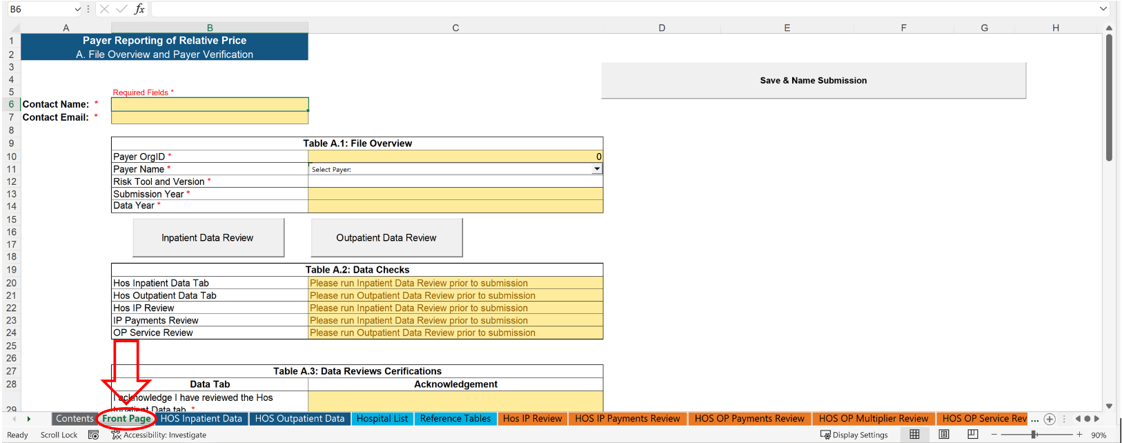

The Front Page tab will look like this:
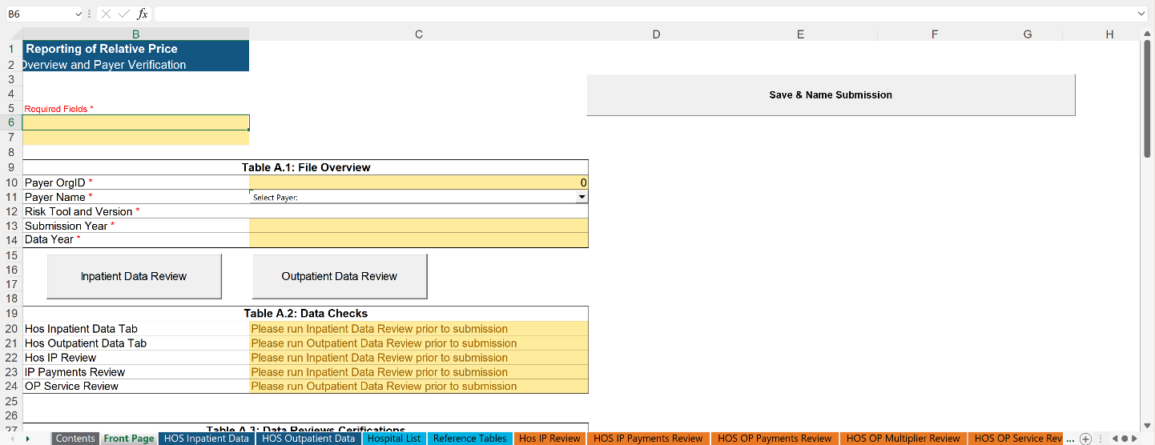
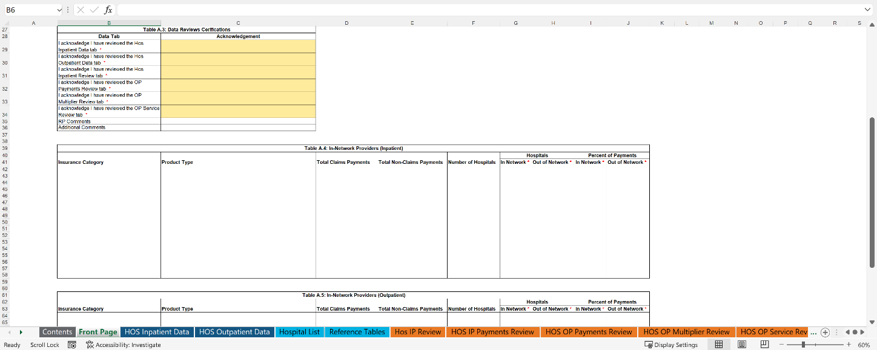
*Each cell highlighted in yellow indicates user attention is needed
- Users must fill out their first and last name in the Contact Name cell and their contact email address in the Contact Email cell.
- Users must complete Table A.1:
  - Select the correct Payer Name for the organization submitting the data. This will automatically populate the Payer OrgID cell which is highlighted in yellow.
  - Enter the Risk Tool and Version used when preparing the data.
  - Input the current year that you are submitting the RP data for in the Submission Year cell.
  - Enter the calendar year that the data represents in the Data Year cell.
- Users must complete Table A.4 and Table A.5:
  - Table A.4 and Table A.5 are summarized tables that are generated once information is properly entered in the “HOS Inpatient Data” and “HOS Outpatient Data” data fields.
  - The last two columns in Tables A.4 and A.5 are entered manually by the data submitter
    - The Hospitals columns are a count of which providers are considered in-network or out-of-network
    - The Percent of Payments columns are a percentage of what payments are considered in-network or out-of-network
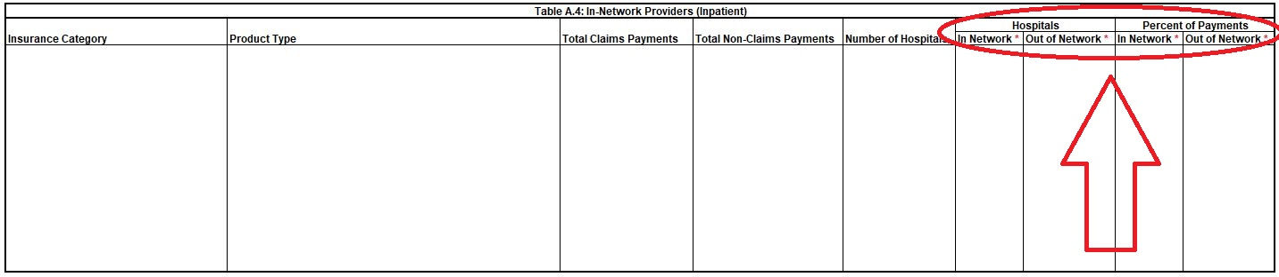

2. Entering Hospital Inpatient RP Data
- Click on the “Hos Inpatient Data” tab located to the right of the “Front Page” tab.
- Users must enter data into columns A though H on the left side of the screen.
- Columns I though M (highlighted in blue) contain data checks for the inputted data. These cells are locked and will auto-populate when validating the entered data.

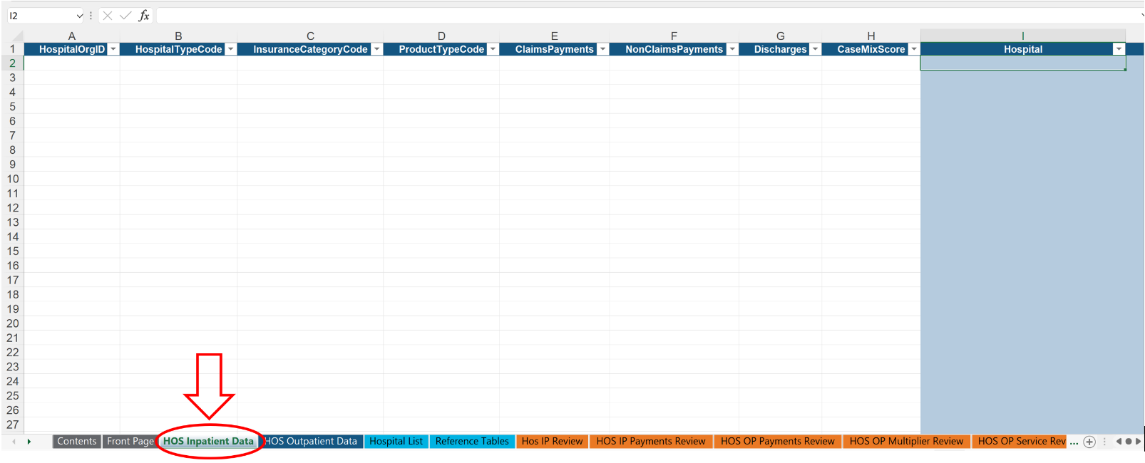

- For details on the data fields to enter, please refer to the Data Specification Manual.

- User reference materials for certain fields are also included within the template on the tabs highlighted in light blue:
  - The Provider List is included on the “Hospital List” tab.
  - The Relative Price Reference Tables from the Data Specification Manual (for the Hospital Type, Insurance Category, Product Type, and Multiplier Indicator) are also included in the “Reference Tables” tab.

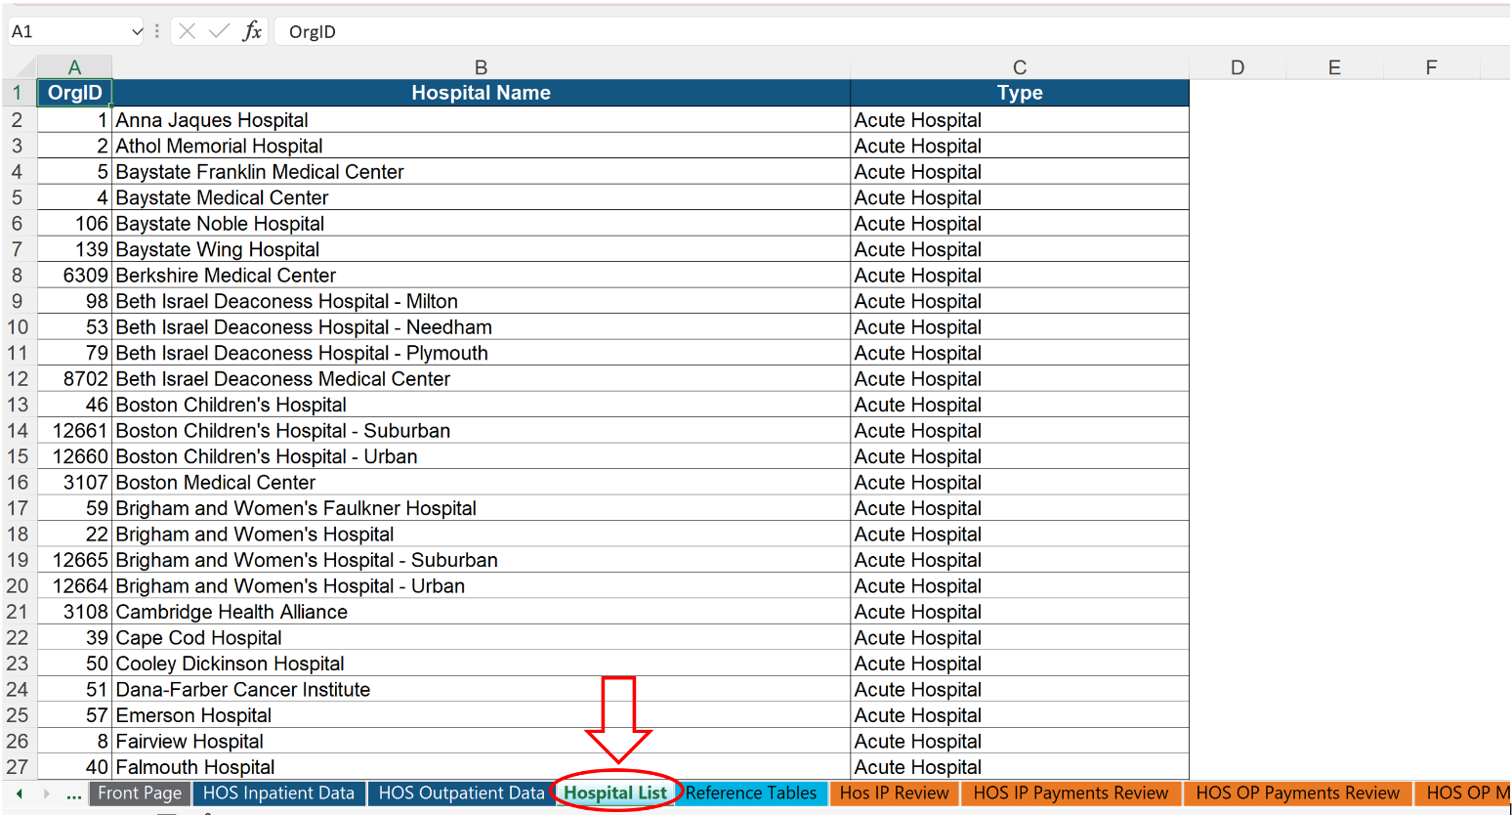

- After entering the inpatient data on the “HOS Inpatient Data” tab, return to the “Front Page” tab of the workbook and click on the Inpatient Data Review button. This will check all the entered data within the “HOS Inpatient Data” tab and populate both the “HOS IP Review” and “HOS IP Payment Review” tabs.

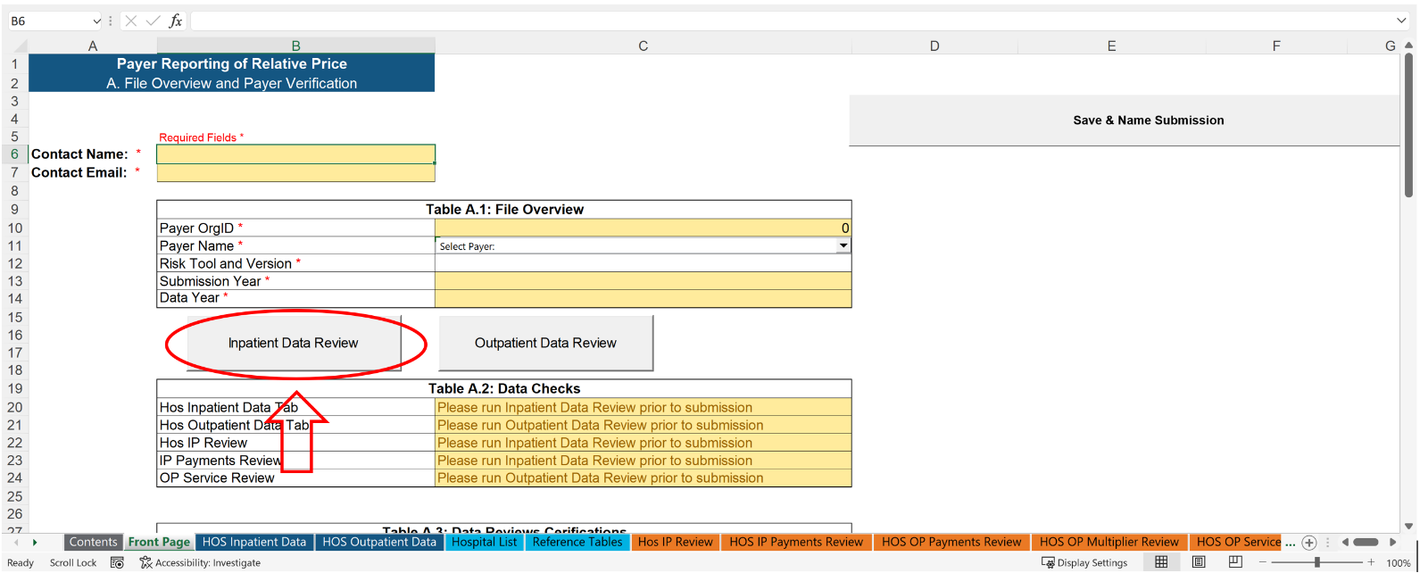
- Return to the “HOS Inpatient Data” tab. Columns I through M will be populated with the results of the data validation. Any invalid data entered will trigger an error message to appear in the blue columns (see example below). Note: the Inpatient Data Review button must be clicked to apply the data checks to all of the entered data.
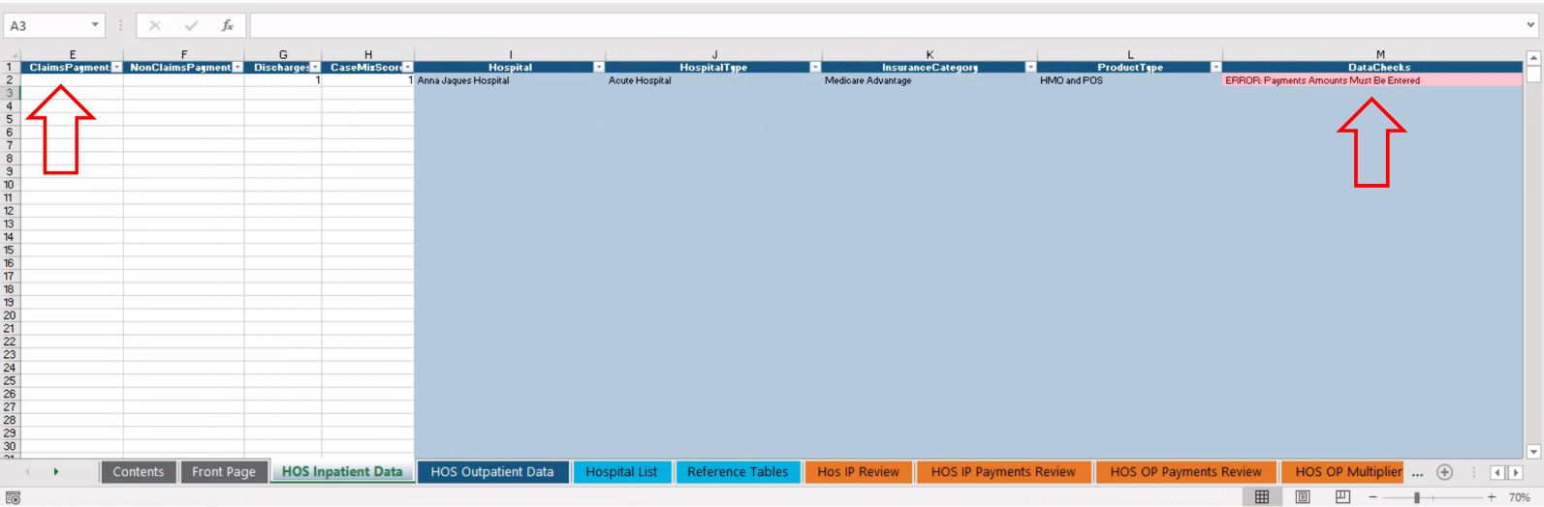

- Click on the “Hos IP Review” tab, this tab checks to ensure that only one line of data was entered for each Hospital/Hospital Type/Insurance Category/Product Type, and provides the payments entered for review. Once the “Hos IP Review” button on the “Front Page” tab is clicked, the data within the “Hos Inpatient Review” can be used by the data submitter to review their data prior to submission.
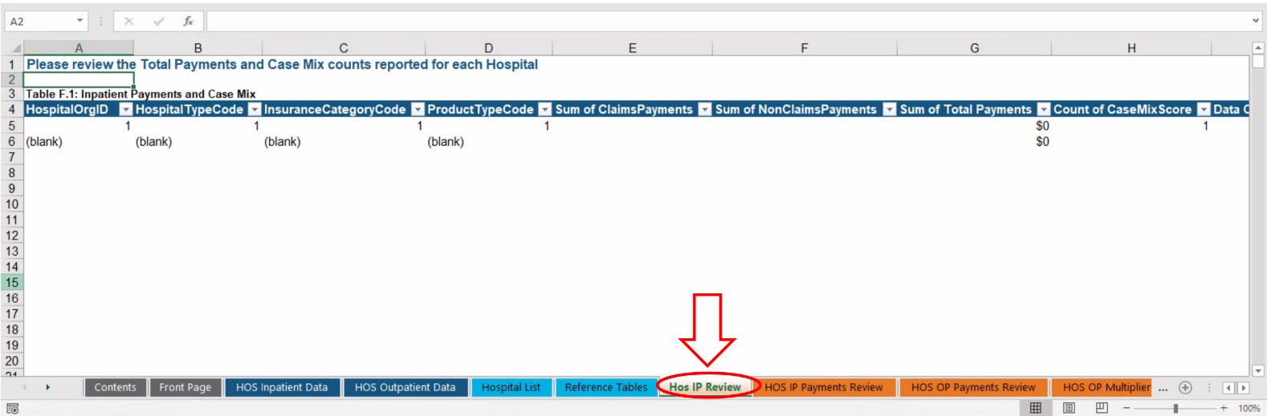

- Click on the “HOS IP Payments Review” tab. This tab checks to ensure that acute hospitals with psych payments are reported as a subset of the total acute hospital payments, and also provides the payments entered for review.

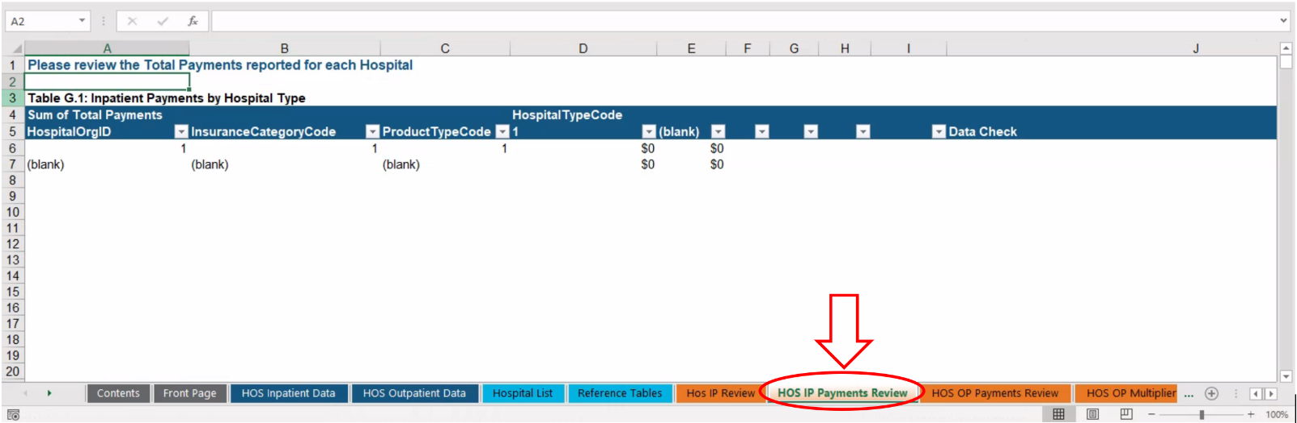

- Return to the “Front Page” tab after correcting any data issues flagged. Table A.2 will no longer be highlighted in yellow or red when the entered data has been validated.

- When the data has been validated, please fill out Table A.3 acknowledging that you have reviewed the data entered and it is correct. There is also space for data submitters to include any relevant comments.

- Fill out table A.4, including the Hospitals and Percent of Payments columns for inpatient. These columns may not appear highlighted, but users will be capable of inputting their in-network and out-of-network information.

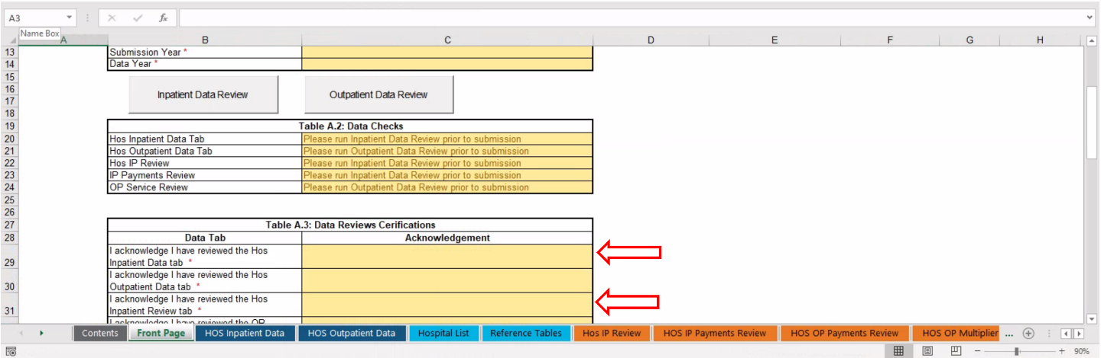

3. Entering Hospital Outpatient RP Data
*Please note that these instructions also work for the Physician Group and Other Provider data templates
- Click on the “HOS Outpatient Data” tab located to the right of the “HOS Inpatient Data” tab.
- Users must enter data in columns A through I on the left side of the screen.
- The columns to the right highlighted in blue contain data checks for the inputted data. These cells are locked and will auto-populate when validating the entered data.

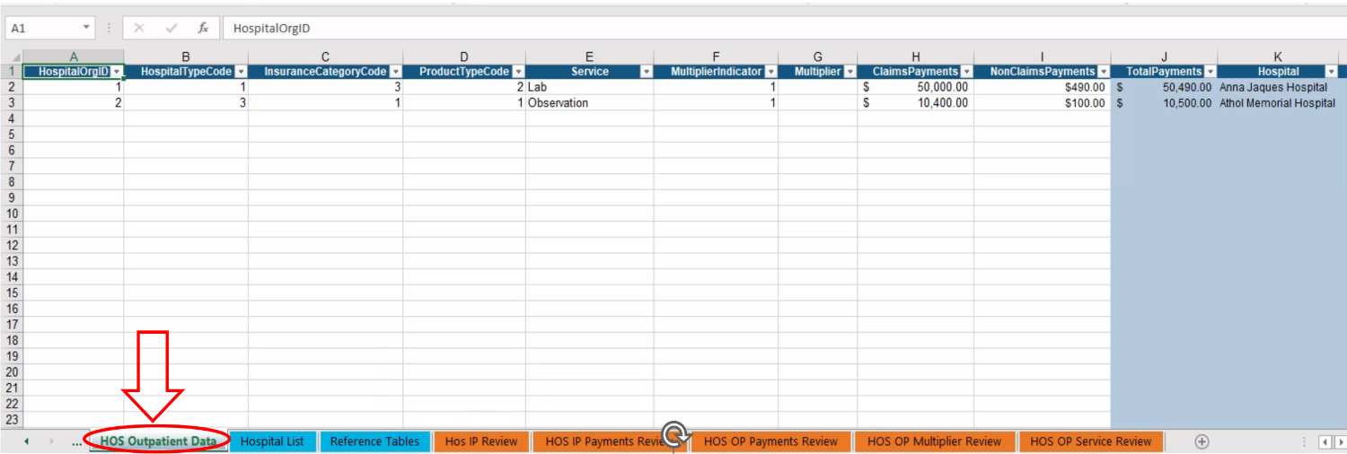

- For details on the data fields to enter, please refer to the Data Specification Manual.
- User reference materials for certain fields are also included within the template on the tabs highlighted in light blue:
  - The Provider List is included on the “Hospital List” tab (or “Physician Group List”, or “Other Provider List” in those respective templates).
  - The Relative Price Reference Tables from the Data Specification Manual (for the Hospital Type, Insurance Category, Product Type, and Multiplier Indicator) are also included in the “Reference Tables” tab.

- Return to the “Front Page” tab and click on the Outpatient Data Review button:

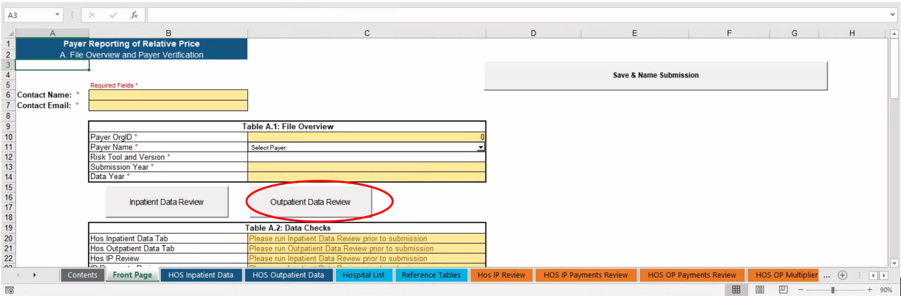

- Return to the “HOS Outpatient Data” tab. Columns J through P will be populated with the results of the data validation. Any invalid data entered will trigger an error message to appear in the blue columns (see example below). Note: the Outpatient Data Review button must be clicked to apply the data checks to all of the entered data.
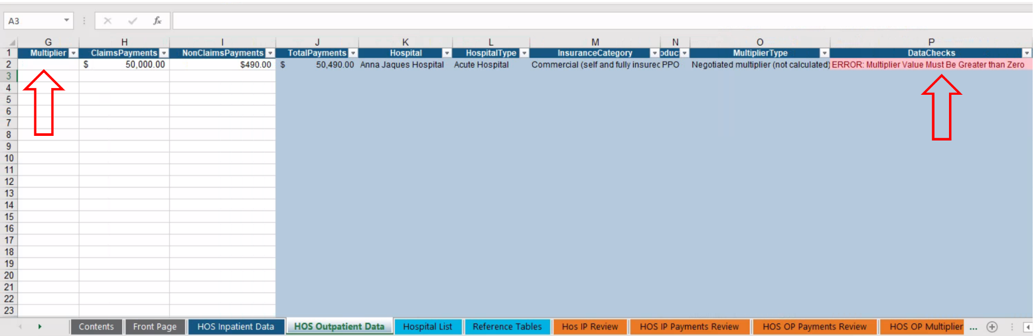
- Click on the “HOS OP Payments Review” tab, this tab shows the total payments entered for each unique Hospital/Hospital Type/Insurance Category/Product Type combination for review.
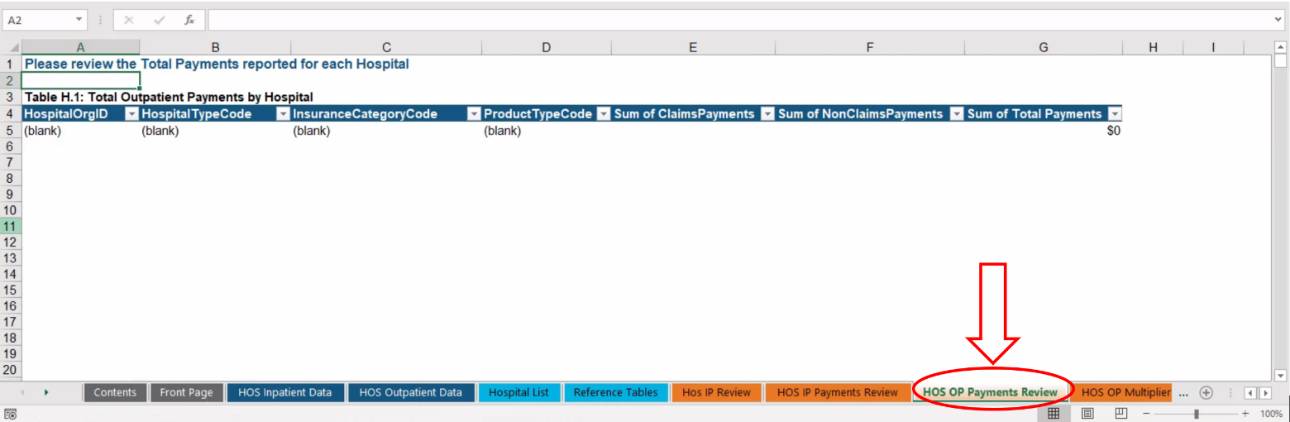

- Click on the “HOS OP Multiplier Review” tab. This includes the range of multipliers and payments entered for review.

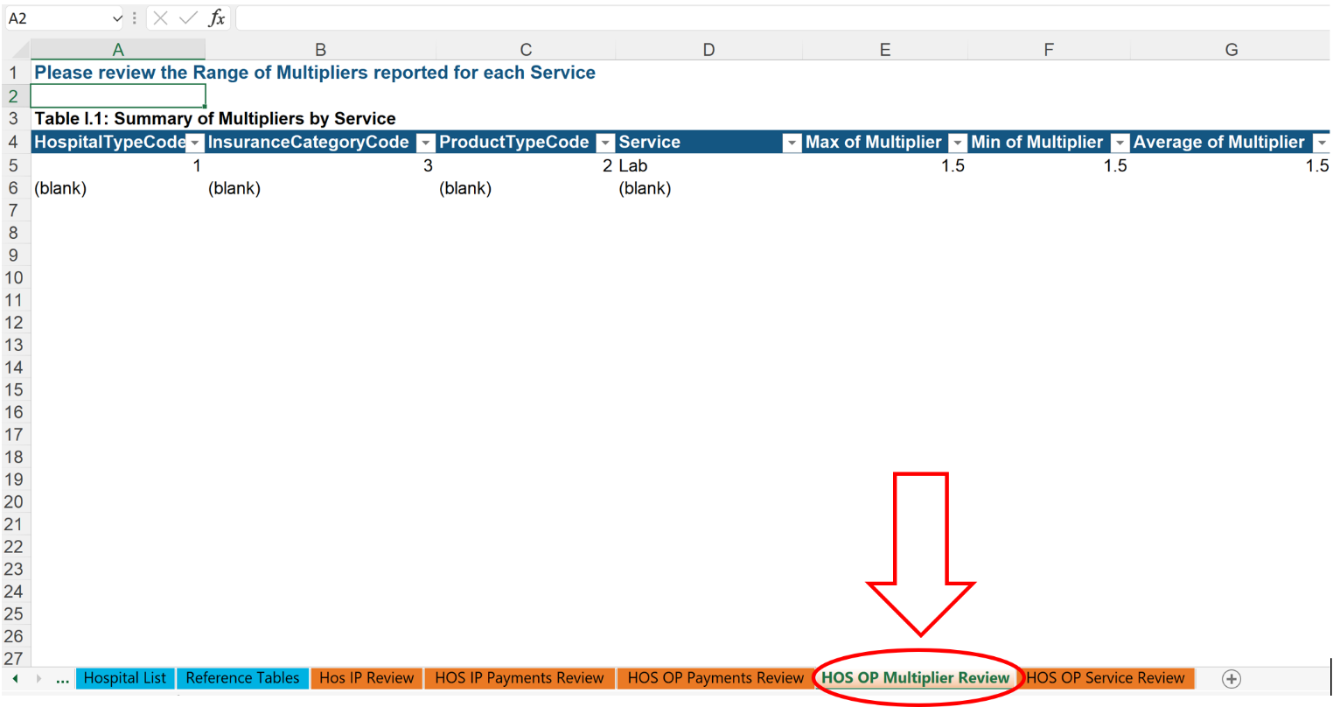

- Click on the “OP Service Review” tab. This tab checks to ensure that only one multiplier was entered for each Hospital/Hospital Type/Insurance Category/Product Type/Service combination (i.e. only one line of data per unique combination).

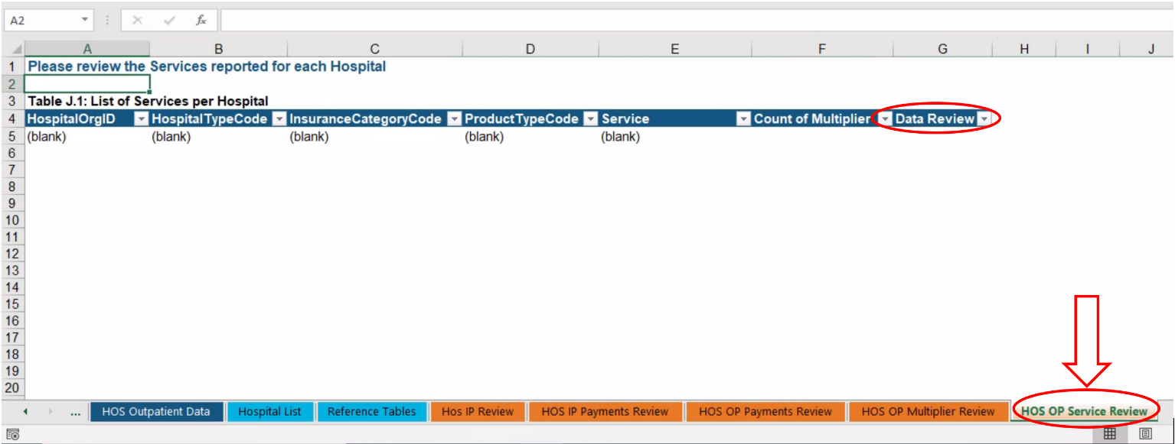

- Return to the “Front Page” tab. Table A.2 will no longer have cells highlighted in yellow or red when all the data has been validated.
- Fill out the remaining content on Table A.3 to confirm that you have reviewed the hospital outpatient data.

- Fill out table A.5, including the Hospitals and Percent of Payments columns for outpatient. These columns may not appear highlighted, but users will be capable of inputting their in-network and out-of-network information.

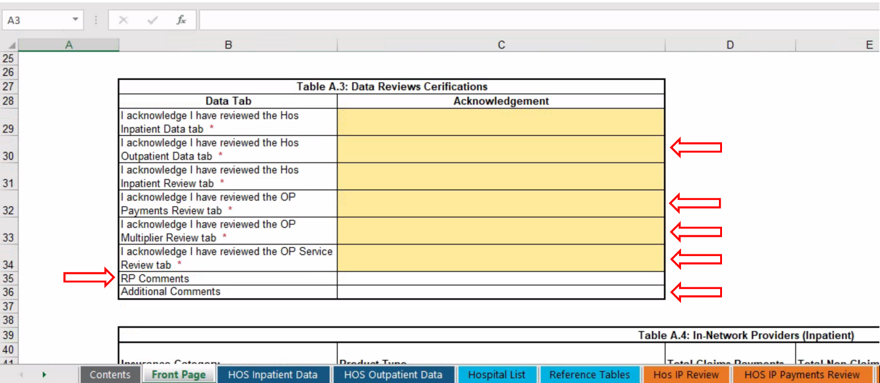
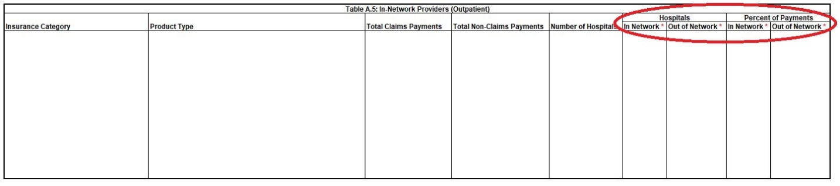

4. Submitting the Data
*Please note that these instructions also work for the Physician Group and Other Provider data templates
- Click on the “Save & Name Submission” button located to the right of the “Front Page” tab.
- If errors are identified in the data, users will not be allowed to save the file until errors are corrected.
- If all data is validated by the data checks, users will be prompted to save the file in the required file name. IMPORTANT: In order for the file to be accepted by the CHIA Submissions upload, it MUST be in the file name generated by the “Save & Name Submission” button.

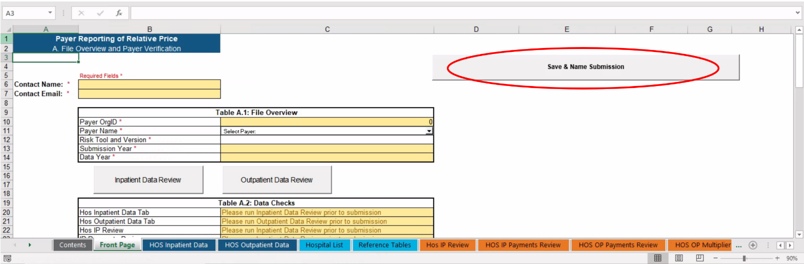

- After saving the file, go to https://chiasubmissions.chia.state.ma.us to access the CHIA Submissions data submission platform. NOTE: CHIA Submissions operates best in Google Chrome

- Users will be prompted to log in. Returning RP data submitters can use the same credentials that were previously used to access INET. New users must register for access. For more information, visit CHIA’s “Information for Data Submitters” web page.

- After logging in, select the File Submissions Application
- Note: Most users will only have one Application, however some users may have access to multiple Applications if the user is responsible for uploading multiple data submissions to CHIA.

- Users will be prompted to select a Submission Type. Please select “Relative Price” from the dropdown menu.
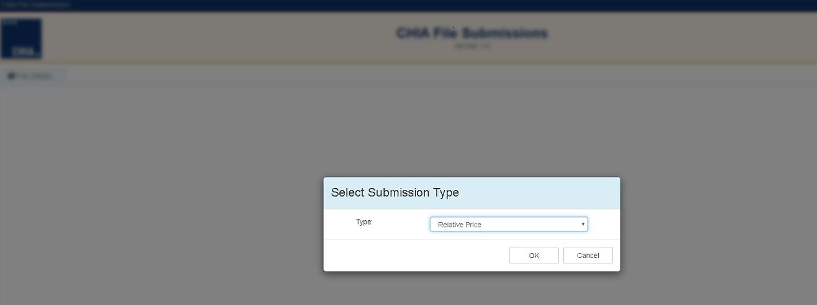

- On the File Submissions page, users can upload a file on the right side of the page.
- Click the “Browse” button and select the RP file in the correct file name structure.
- After selecting the file, click the “Save and Upload” button on the top right corner. Files that have been submitted will be shown on the left side of the screen.
