

Document Revision History

|  |  |  |  |  |
| --- | --- | --- | --- | --- |
| Date | Version Number | Writer | Requested by: | Key Changes: |
| July 2016 | Release Copy - V1.0 | K. Walsh | C. Herrera |  |
| August 2016 | Release Copy - V1.1 | K. Walsh | C. Herrera | 1) Age - clarification on Age calculation method  2) Added detail in Data Delivery for File format detail and linkage description  3) Updated Zip Code content  4) Added Grouper content with year over year table reference |
|  |  |  |  |  |
|  |  |  |  |  |

Contents

Executive Summary 6

Part A. Data Collection 7

Verification Report Process 7

Part B: Core Data Elements 9

Data Elements Available for LDS and Government Users 9

Condition Present on Admission (POA) Indicators 9

Diagnosis and Procedure Codes 9

Emergency Department (ED) Flag 9

Ethnicity 9

External Cause of Injury Code (E-Code) 9

Hispanic Indicator 9

Homeless Indicator 10

Leave of Absence (LOA) Days 10

Outpatient Observation Stay Flag 10

Organization Identifiers (ORG ID) 10

Other Caregiver 10

Patient Status 11

Zip Code 13

Payer Codes 13

Race 13

Revenue Codes 14

Source of Admission 14

Data Available for Government Users Only 15

Do Not Resuscitate (DNR) Status 15

Mother’s Medical Record Number 15

Other Ethnicity 15

Other Race 15

Part C: Derived Data 16

FY15 HIDD Groupers 16

HIDD Groupers Across Years Table 17

All Patient Refined Grouper (3M™ APR-DRGs 20.0, 26.1, and 30.0) 18

CMS-DRG 32.0 18

Severity of Illness and Risk of Mortality 18

Major Diagnostic Category (MDC) 19

Calculated Fields Available For LDS and Government Users 20

Age LDS (formerly Patient Age) 20

Days Between Stays 20

Length of Stay (LOS) 20

Preoperative Days 20

Unique Health Information Number (UHIN) 21

Mother’s UHIN 21

**UHIN Sequence Number** 21

Unique Physician Number (UPN) 22

Part D: Data Limitations 23

Race and Ethnicity Data 23

Historical Data Elements 23

SUPPLEMENT 1. Applying For and Using CHIA Data 25

Applying for CHIA Data 25

How to Apply for the Data 25

Securing CHIA Data Prior to Use 25

Data Delivery 25

Hardware Requirements: 25

CD Contents: 26

File Formats Available 26

Hospital Location and ORG IDs 31

# Executive Summary

The FY2015 Hospital Inpatient Discharge Database Guide provides general information about CHIA’s most recent inpatient data holdings.

Each quarter, Massachusetts acute care hospitals provide CHIA with inpatient information that CHIA transforms into annual hospital inpatient discharge databases (HIDDs). This data is provided for all hospital patients, regardless of residency or payer type. The FY2015 HIDD includes all reported inpatient discharges that occurred between October 1, 2014 and September 30, 2015. Acute care hospitals reported to CHIA the occurrence of 796,835 inpatient discharges for FY2015.

The information in this guide is limited to high level data notes. The document describes how the data was collected, a description of selected data elements, derived data elements, and data limitations. As always, CHIA strongly suggests that users perform some qualitative checks of the data prior to drawing conclusions about that data.

**New in FY 2015**

CHIA has created new, CHIA Limited Data Set (LDS) users to allow more flexibility in data use. Information about the application process is available in *SUPPLEMENT 1. Applying For and Using CHIA Data.*

CHIA will report diagnoses and procedure codes from Providers, who are using the codes supplied via the International Classification of Diseases, Ninth Revision, and Clinical Modification (**ICD**-**9**-**CM**). While CHIA has lifted the limit on the number of diagnosis and procedure codes in the FY2015 release, there are no ICD-10-CM codes in this dataset.

# Part A. Data Collection

Acute hospitals in Massachusetts are required to submit discharge data to CHIA under ***957 CMR 8.00 - APCD and Case Mix Data Submission*** and *Regulation 957 CMR 5.00: Health Care Claims, Case Mix and Charge Data Release Procedures*. Researchers can access HIDD regulations by visiting CHIA’s web site [<http://www.chiamass.gov/regulations>] or by faxing a request to CHIA at 617-727-7662.

***957 CMR 8.00 - APCD and Case Mix Data Submission***requires acute care hospitals to submit discharge data to CHIA 75 days after each quarter. The quarterly reporting intervals for the 2015 HIDD are as follows:

**Quarter 1:** October 1, 2014 - December 31, 2014

**Quarter 2:** January 1, 2015 – March 31, 2015

**Quarter 3**: April 1, 2015 – June 30, 2015

**Quarter 4:** July 1, 2015 – September 30, 2015

CHIA reviews each hospital’s quarterly data for compliance with ***957 CMR 8.00 - APCD and Case Mix Data Submission***using a one percent error rate. The one percent error rate is based upon the presence of one or more errors per discharge for the hospital’s quarterly submission. CHIA checks for valid codes, correct formatting, and presence of the required data elements. If one percent or more of the discharges are rejected, CHIA rejects the entire submission.

Each hospital receives a quarterly error report displaying invalid discharge information. Quarterly data that does not meet the one percent compliance standard must be resubmitted by the reporting hospital until the standard is met.

## Verification Report Process

Annually CHIA sends each hospital a report on their discharge data to maintain and improve the quality of their submissions. The Verification Report process gives the hospitals the opportunity to review the data they have provided to CHIA and affirm data accuracy.

CHIA produces hospital specific Verification Reports after each hospital successfully submits four quarters of data. CHIA asks each hospital to review and verify the data contained within the report. Each Verification Report has a series of frequency tables for selected data elements that include, but are not limited to, the number of discharges per month and breakouts by admission type, admission source, race, and disposition.

Hospitals must affirm that reported data is accurate or identify any discrepancies. Hospitals certify the accuracy of their data by completing a Verification Report Response form. CHIA accepts two response types from hospitals:

**A**: A hospital indicates its agreement that the data appearing on the Verification Report is accurate and that it represents the hospital’s case mix profile.

**B:** A hospital indicates that the data on the report is accurate except for the discrepancies noted. If any data discrepancies exist, CHIA requests that hospitals provide written explanations of the discrepancies.

Users interested in the FY2015 HIDD Verification Reports should contact CHIA at [CaseMix.data@state.ma.us](mailto:CaseMix.data@state.ma.us). Please indicate the fiscal year of the Verification Report, the dataset name, and if you need information for a specific hospital or set of hospitals.

# Part B: Core Data Elements

The purpose of the following section is to provide the user with an explanation of some of data, and to give a sense of their reliability. For more information about specific data elements, hospital reporting thresholds, or other questions about the data, please contact CHIA by emailing [CaseMix.data@state.ma.us](mailto:CaseMix.data@state.ma.us).

## Data Elements Available for LDS and Government Users

### Condition Present on Admission (POA) Indicators

These flags indicate the onset of a diagnosis preceded or followed admission. There is a POA indicator for every diagnosis and E-code field.

### Diagnosis and Procedure Codes

In FY2015, CHIA removed the limit on the number of diagnosis and procedure codes submitted and released. In FY2015, 32% of discharges have greater than 15 diagnoses. Discharges reached a maximum of 107 diagnosis codes, and a maximum of 68 procedure codes.

### Emergency Department (ED) Flag

The ED Flag is used to identify patients admitted from the hospital’s emergency department and with previous ED utilization.

### Ethnicity

Beginning October 1, 2006, HIDD includes two main fields to report Ethnicity: Ethnicity 1 and Ethnicity 2. The ethnicity codes are based on the CDC race/ethnicity code [http://www.cdc.gov/nchs/data/dvs/Race_Ethnicity_CodeSet.pdf].

### External Cause of Injury Code (E-Code)

This data element describes the principal external cause of injuries, poisonings, and adverse effects using ICD-9 codes. In addition to the dedicated E-Code field, hospitals record additional E-Codes in the associated diagnosis fields for conditions having multiple causes.

### Hispanic Indicator

A flag for patients of Cuban, Mexican, Puerto Rican or Central American or other Spanish or other Spanish culture or origin regardless of race.

### Homeless Indicator

This flag indicates that the patient was homeless at the time of discharge.

### Leave of Absence (LOA) Days

Hospitals report leave of absence days when used by the patient. These are the number of days of a patient's absence with physician approval during a hospital stay without formal discharge and readmission to the facility. These days cannot be greater than the total length of stay. CHIA cannot verify the use of these days if they are not reported, nor can CHIA verify the number reported when a hospital provides the information. The validity of this data element relies solely on the accuracy of a given hospital’s reporting practices.

### Outpatient Observation Stay Flag

This flags indicates that the patient was admitted from the hospital’s outpatient observation department or had prior outpatient utilization.

### Organization Identifiers (ORG ID)

CHIA FY2015 contains four organization identifier fields. These fields are a CHIA assigned unique code for each Massachusetts hospital:

* Massachusetts Filer Organization ID (IdOrgFiler) – The Organization ID for the hospital that submitted the inpatient discharge data to CHIA.
* Massachusetts Site Organization ID (IdOrgSite) - The Organization ID for the site where the patient received inpatient care.
* Massachusetts Hospital Organization ID (IdOrgHosp) - The Organization ID for the main hospital affiliation. For example 3108 (Cambridge Health Alliance) is the IdOrgHosp for the IdOrgSite 142 (Whidden Hospital).
* Massachusetts Transfer Hospital Organization ID (IdOrgTransfer) – is the Organization ID for the facility from which a patient is transferred. If the patient is transferred from outside of Massachusetts, the IdOrgTransfer will be 9999999.

### Other Caregiver

This data element indicates the type of primary caregiver responsible for the patient’s care other than the attending physician, operating room physician, or nurse midwife as specified in the Regulation. Other caregiver codes include resident, intern, nurse practitioner, and physician’s assistant.

### Patient Status

This field identifies the disposition and destination of the patient when discharged from the hospital.

1. Patient Status Codes

| **Patient Disposition Codes** | **Discharge Circumstances and Patient Destination** |
| --- | --- |
| **1** | Discharged/transferred to home or self-care (routine discharge) |
| **2** | Discharged/transferred to another short-term general hospital for inpatient care |
| **3** | Discharged, transferred to Skilled Nursing Facility (SNF) |
| **4** | Discharged/transferred to an Intermediate Care Facility (ICF) |
| **5** | Discharged/transferred to a Designated cancer Center or Children’s Hospital |
| **6** | Discharged/transferred to home under care of organized home health service organization |
| **7** | Left against medical advice |
| **8** | Discharged/transferred to home under care of a Home IV Drug Therapy Provider |
| **12** | Discharge Other |
| **13** | Discharge/transfer to rehab hospital |
| **14** | Discharge/transfer to rest home |
| **15** | Discharge to Shelter |
| **20** | Expired (or did not recover - Christian Science Patient) |
| **50** | Discharged to Hospice - Home |
| **51** | Discharged to Hospice Medical Facility |
| **43** | Discharged/transferred to federal healthcare facility |
| **61** | Discharged/transferred within this institution to a hospital-based Medicare-approved swing bed |
| **62** | Discharged/transferred to an inpatient rehabilitation facility (IRF) including rehabilitation distinct part units of a hospital. |
| **63** | Discharge/transfer to a Medicare certified long term care hospital. |
| **64** | Discharged/transferred to a nursing facility certified under Medicaid but not certified under Medicare |
| **65** | Discharged/transferred to psychiatric hospital or psychiatric distinct part unit of a hospital. |
| **66** | Discharged/transferred to a Critical Access Hospital (CAH). |
| **69** | Discharged/transferred to a designated disaster alternative care site |
| **70** | Discharged/transferred to another type of health care institution not defined elsewhere in code list. |
| **81** | Discharged to home or self-care with a planned acute care hospital readmission |
| **82** | Discharged/transferred to a short term general hospital for inpatient care with a planned acute care hospital inpatient readmission |
| **83** | Discharged/transferred to a skilled nursing facility (SNF) with Medicare certification with a planned acute care hospital inpatient readmission |
| **84** | Discharged/transferred to a facility that provides custodial or supportive care with a planned acute care hospital inpatient readmission |
| **85** | Discharged/transferred to a designated cancer center or children’s hospital with a planned acute care hospital inpatient readmission |
| **86** | Discharged/transferred to home under care of organized home health service organization with a planned acute care hospital inpatient readmission |
| **87** | Discharged/transferred to court/law enforcement with a planned acute care hospital inpatient readmission |
| **88** | Discharged/transferred to a federal health care facility with a planned acute care hospital inpatient readmission |
| **89** | Discharged/transferred to a hospital-based Medicare approved swing bed with a planned acute care hospital inpatient readmission |
| **90** | Discharged/transferred to an inpatient rehabilitation facility (IRF) including rehabilitation distinct part units of a hospital with a planned acute care hospital inpatient readmission |
| **91** | Discharged/transferred to a Medicare certified long term care hospital (LTCH) with a planned acute care hospital inpatient readmission |
| **92** | Discharged/transferred to nursing facility certified under Medicaid but not certified under Medicare with a planned acute care hospital inpatient readmission |
| **93** | Discharged/transferred to a psychiatric hospital/distinct part unit of a hospital with a planned acute care hospital inpatient readmission |
| **94** | Discharged/transferred to a critical access hospital (CAH) with a planned acute care hospital inpatient readmission |
| **95** | Discharged/transferred to another type of health care institution not defined elsewhere in this code list with a planned acute care hospital inpatient readmission |

A small percentage of records are missing the zero used to pad codes 10 thru 18. For example, the entire code might consist of the digit 7, rather than 07.

### Zip Code

If unknown or if the patient country is not the United States, zip codes must be set to zeros (0s). The Limited Data Set supports selection of 3-character Zip Code or 5-character Zip Code for approval by CHIA, in relation to other data elements that are considerate of patient privacy. Any additional questions can be addressed by contacting CHIA at [CaseMix.data@state.ma.us](mailto:CaseMix.data@state.ma.us).

### Payer Codes

There are four Payer Codes: Payer Code 1, Payer Code 2, Primary Payer Type, and Secondary Payer Type. The Payer codes indicate the source of the specific health care coverage plan, such as Harvard Pilgrim Health Plan or Tufts Associated Health Plan. The payer types are the general payer category, such as HMO, Commercial, or Workers’ Compensation.

### Race

Prior to October 1, 2006, there was a single field to report patient race. Beginning   
October 1, 2006, there were two main fields to report race: Race 1, Race 2, and Other Race.

Beginning in FY2007, the CHIA’s predecessor agency adopted federal Office of Management and Budget standard race and ethnicity values that were consistent with CDC standards.**[1]**

1. Race Codes

|  |  |
| --- | --- |
| Race Codes (As of FY 2007) | Description |
| R1 | American Indian /Alaska Native |
| R2 | Asian |
| R3 | Black/African American |
| R4 | Native Hawaiian or Other Pacific Islander |
| R5 | White |
| R9 | Other Race |
| UNKNOW | Unknown/not specified |

Users seeking to compare pre-FY2000 HIDD to data submitted between FY2000 – FY2006, will need to standardize race codes using the translation table below.

1. Race Codes prior to FY2006

| Race Code | FY2000 – FY2006 | Pre-2000 |
| --- | --- | --- |
| 1 | White | White |
| 2 | Black | Black |
| 3 | Asian | Other |
| 4 | Hispanic | Unknown |
| 5 | American Indian | American Indian |
| 6 | Other | Asian |
| 9 | Unknown | Hispanic |

### Revenue Codes

Revenue Codes coincide with the current UB-04 Revenue Codes, which became effective on March 1, 2007.

### Source of Admission

The two sources of admission codes indicate the source of referring or transferring the patient to inpatient status in the hospital. Primary Source of Admission is the originating, referring, or transferring facility or primary referral source causing the patient to enter the hospital. Secondary Source of Admission accommodates patients’ two sources of admission (for example, patients who transferred twice prior to admission).

In January 1994, three new sources of admission were added: ambulatory surgery, observation, and extramural birth (for newborns).

The codes were further expanded effective October 1, 1997, to better define each admission source. Physician referral was further clarified as “Direct Physician Referral” versus calling a health plan for an HMO Referral or Direct Health Plan Referral.” “Clinic Referral” was separated into “Within Hospital Clinic Referral” and “Outside Hospital Clinic Referral.” And “Emergency Room Transfer” was further delineated to include “Outside Hospital Emergency Room Transfers” and “Walk-In/Self- Referrals.”

It is important to note that the code “*Transfer from Within Hospital Emergency Room*” is intended to be used as a Secondary Source of Admission only, except in cases where the hospital is unable to determine the originating or primary source of admission.

## Data Available for Government Users Only

### Do Not Resuscitate (DNR) Status

This element indicates that the patient has a physician order not to resuscitate or the patient had a status of receiving palliative care only.

### Mother’s Medical Record Number

The medical record number assigned within the hospital to the newborn’s mother. This medical record number distinguishes the patient’s mother and the patient’s mother’s hospital record(s) from all others in that institution.

### Other Ethnicity

Other Ethnicityis a free text field for reporting any additional ethnicities available only to Government Users.

### Other Race

Other Race is an open text field for reporting additional races when Race 1 or Race 2 equals “R9”, or “Other Race”.

Part C: Derived Data

CHIA produces from the discharge data a number of derived elements and enhancements. These include Groupers and Calculated Fields.

## FY15 HIDD Groupers

For researcher convenience, CHIA performs data grouping using 3M™ APR-DRG groupers. For the FY2015 HIDD, CHIA calculated three All Patient Refined (APR) Diagnostic Related Groups (DRGs) and one Medicare (CMS) Diagnosis Related Grouper (Table 2). For each APR-DRG type, CHIA also calculated the Major Diagnosis Category, and two subclasses (Severity of Illness and Risk of Mortality) for each discharge.

1. FY2015 HIDD Groupers

|  |  |  |  |  |
| --- | --- | --- | --- | --- |
| Grouper | Available | Major Diagnostic Category Field | Severity of Illness Field | Risk of Mortality Field |
| APR-DRG 20.0 | FY2007-FY2015 | Yes | Yes | Yes |
| APR–DRG 26.1 | FY2009-FY2015 | Yes | Yes | Yes |
| APR–DRG 30.0 | FY2009-FY2015 | Yes | Yes | Yes |
| CMS-DRG 32.0 | FY2015 | Yes | n/a | n/a |

### HIDD Groupers Across Years Table

|  |  |  |  |  |  |  |  |  |  |  |  |  |  |  |  |  |  |  |  |  |  |
| --- | --- | --- | --- | --- | --- | --- | --- | --- | --- | --- | --- | --- | --- | --- | --- | --- | --- | --- | --- | --- | --- |
| **HIDD** | **AP-DRG (APD)** | | | | | **APR-DRG Version 12** | | | | | **VHAF - DRG** | | **CMS - DRG** | | | | | | | | |
| **FISCAL YEAR** | **V 12** | **V 14.1** | **V 18** | **V 21** | **V 25.1** | **V 12** | **V 15** | **V 20** | **V 26.1** | **V 30** | **V 24** | **V 25** | **V 2 (fHCFA)** | **V 8 (fHCFA)** | **V 26** | **V 27** | **V 28** | **V 29** | **V 30** | **V 31** | **V 32** |
| **2015** |  |  |  |  |  |  |  |  |  |  |  |  |  |  |  |  |  |  |  |  | **X** |
| **2014** |  |  |  |  |  |  |  | **X** | **X** | **X** |  |  |  |  |  |  |  |  |  | **X** |  |
| **2013** |  |  |  | **X** | **X** |  |  | **X** | **X** | **X** |  |  |  |  |  |  |  |  | **X** |  |  |
| **2012** |  |  |  | **X** | **X** |  |  | **X** | **X** | **X** |  |  |  |  |  |  |  | **X** |  |  |  |
| **2011** |  |  |  | **X** | **X** |  |  | **X** | **X** | **X** |  |  |  |  |  |  | **X** |  |  |  |  |
| **2010** |  |  |  | **X** | **X** |  |  | **X** | **X** | **X** |  |  |  |  |  | **X** |  |  |  |  |  |
| **2009** |  |  |  | **X** | **X** |  |  | **X** | **X** | **X** |  |  |  |  | **X** |  |  |  |  |  |  |
| **2008** | **X** |  |  | **X** |  |  |  | **X** |  |  |  | **X** |  |  |  |  |  |  |  |  |  |
| **2007** | **X** |  |  | **X** |  |  |  | **X** |  |  | **X** |  |  |  |  |  |  |  |  |  |  |
| **2006** | **X** | **X** | **X** | **X** |  |  | **X** |  |  |  |  |  |  |  |  |  |  |  |  |  |  |
| **2005** | **X** | **X** | **X** |  |  |  | **X** |  |  |  |  |  |  |  |  |  |  |  |  |  |  |
| **2004** | **X** | **X** | **X** |  |  |  | **X** |  |  |  |  |  |  |  |  |  |  |  |  |  |  |
| **2003** | **X** | **X** | **X** |  |  |  | **X** |  |  |  |  |  |  |  |  |  |  |  |  |  |  |
| **2002** | **X** | **X** | **X** |  |  |  | **X** |  |  |  |  |  |  |  |  |  |  |  |  |  |  |
| **2001** | **X** | **X** | **X** |  |  |  | **X** |  |  |  |  |  |  |  |  |  |  |  |  |  |  |
| **2000** | **X** | **X** | **X** |  |  |  | **X** |  |  |  |  |  |  | **X** |  |  |  |  |  |  |  |
| **1999** | **X** | **X** | **X** |  |  | **X** | **X** |  |  |  |  |  |  | **X** |  |  |  |  |  |  |  |
| **1998** | **X** | **X** | **X** |  |  | **X** | **X** |  |  |  |  |  |  | **X** |  |  |  |  |  |  |  |
| **1997** | **X** | **X** | **X** |  |  | **X** | **X** |  |  |  |  |  |  | **X** |  |  |  |  |  |  |  |
| **1996** | **X** | **X** | **X** |  |  | **X** | **X** |  |  |  |  |  |  | **X** |  |  |  |  |  |  |  |
| **1995** | **X** | **X** | **X** |  |  | **X** | **X** |  |  |  |  |  |  | **X** |  |  |  |  |  |  |  |
| **1994** | **X** | **X** | **X** |  |  | **X** | **X** |  |  |  |  |  |  | **X** |  |  |  |  |  |  |  |
| **1993** | **X** |  |  |  |  | **X** |  |  |  |  |  |  |  | **X** |  |  |  |  |  |  |  |
| **1992** | **X** |  |  |  |  | **X** |  |  |  |  |  |  |  | **X** |  |  |  |  |  |  |  |
| **1991** | **X** |  |  |  |  | **X** |  |  |  |  |  |  | **X** | **X** |  |  |  |  |  |  |  |
| **1990** | **X** |  |  |  |  | **X** |  |  |  |  |  |  | **X** | **X** |  |  |  |  |  |  |  |
| **1989** | **X** |  |  |  |  |  |  |  |  |  |  |  | **X** | **X** |  |  |  |  |  |  |  |
| **1988** |  |  |  |  |  |  |  |  |  |  |  |  | **X** | **X** |  |  |  |  |  |  |  |

### All Patient Refined Grouper (3M™ APR-DRGs 20.0, 26.1, and 30.0)

The All Patient Refined DRGs (3M APR-DRG) is a severity/risk adjusted classification system that provides a more effective means of adjusting for patient differences**.** APR-Version 30.0is an update to the previously used APR Version 26.1. Versions 20.0 and 26.1 are provided for use by researchers interested in longitudinal analysis. However, analysis of groupers from previous time periods should be performed cautiously.

### CMS-DRG 32.0

The Centers for Medicare and Medicaid Services (CMS) updates its grouper annually, at presentCMS-DRG Version 32.0 has replaced Version 31.0.

### Severity of Illness and Risk of Mortality

Severity of Illness (SOI)and Risk of Mortality(ROM)subclassesrelate to distinct patient attributes. SOI relates to the extent of physiologic decompensation or systematic loss of organ function experienced by the patient, while ROM relates to the likelihood of dying. For example, a patient with acute cholecystitis as the only secondary diagnosis is considered a major SOI but a minor ROM. The SOI is major since there is significant organ system loss of function associated with acute cholecystitis. However, it is unlikely that the acute cholecystitis alone will result in death, thus the ROM for this patient is minor. If additional diagnoses are present along with the acute cholecystitis, patient SOI and ROM may increase. For example, if peritonitis is present along with the acute cholecystitis, the patient is considered an extreme SOI and a major ROM.

Since SOIand ROM are distinct patient attributes, separate subclasses are assigned to a patient for severity of illness and risk of mortality. Thus, in the APR-DRG system, a patient is assigned four distinct descriptors for the SOI and for the ROM, numbered sequentially from 0 to 4.

The SOI and ROM subclass data elements can be found in the HIDD Discharge File Table Summary[2][3]. CHIA recommends that researchers seeking to evaluate resource use or establishing patient care guidelines use the 3M™ APR-DRGs in conjunction with SOI subclass. Researchers seeking to evaluate patient mortality, should use the 3M™ APR-DRGs in conjunction with the ROM subclass.

### Major Diagnostic Category (MDC)

The Major Diagnostic Categories (MDC) is a classification system that parses all principal diagnoses into one of 25 categories primarily for use with DRGs and reimbursement activity. Each category relates to a physical system, disease, or contributing health factor.

## Calculated Fields Available For LDS and Government Users

### Age LDS (formerly Patient Age)

If the date of birth and admission date are valid, then CHIA calculates Age LDS in years.

The calculation is as follows:

* If Admission before Birth Day, then Age = Admission Year –Birth Year– 1
* If Admission on/after Birth Day, then Age = Admission Year – Birth Year
* If Admission Year<=Birth Year and MDC=15, then Age=0
* Where AgeLDS is valid and < 90, set AgeLDS = Age;

______________________________________________________________________

* Where AgeLDS is valid and > 89 and <= 115, set AgeLDS = 999
* Else, where Age is Invalid*, set AgeLDS = null;

*Invalid is defined as missing, negative value or value > 115

Discretion should be used whenever a questionable age assignment is noted. Researchers are advised to consider other data elements in their analysis of this field.

### Days Between Stays

This calculated field indicates the number of days between each discharge and each consecutive admission for applicable patients. That is, a match with the UHIN only is used to make a determination that a patient has been readmitted.

### Length of Stay (LOS)

CHIA calculates Length of Stay (LOS) by subtracting the Admission Date from the Discharge Date and then subtracting Leave of Absence Days (LOA) days). The formula used is

**LOS = Discharge Date – Admission Date – LOA days +1**

CHIA cleans the data according to the following rules:

* Same day discharges are calculated to have a LOS=1.
* If either the Admission Date or Discharge Date are invalid, LOS =0.
* Patient stays ending beyond the end of the reporting year are adjusted to give the correct LOS.

### Preoperative Days

Preoperative Days refer to the time between admission and the execution of a specific procedure. For FY2015, CHIA is only releasing the Preoperative Days for the Principal Procedure. CHICA calculates Preoperative days by subtracting the patient’s admission date from the surgery date. A procedure performed on the day of admission will have Preoperative Days=0. One performed on the day after admission will have Preoperative Days=1.

The formula is as follows:

**Preoperative Days = Procedure Date – Admission Date**

For procedures performed before the day of admission, a negative sign (-) appears in the first position of the Preoperative Days field. If there is no procedure date, or if the procedure date or admission date is invalid, or if the procedure date occurs after the discharge date, then preoperative days is set to 0000.

### Unique Health Information Number (UHIN)

Each patient is given by CHIA a Unique Health Information Number (UHIN), which is a surrogate key that can link patients over time and across hospitals. The data element is blank, a single dash (-) appears in the UHIN field. It is valid for hospitals to report that the unique patient identifier is unknown. In these cases, the UHIN appears as ‘000000001’.

The utility of the UHIN field is dependent on the reporting data. For a small number of hospitals, little or no UHIN data exists, as these hospitals failed to report patients’ uniquely identified information. Other hospitals reported the same data repeatedly, resulting in numerous admissions for one UHIN. In other cases, the demographic information (age, sex, etc.) was not consistent when a match did exist with the UHIN. Some explanations for this include assignment of a mother’s unique identifiers to her infant or assignment of a spouse’s unique identifiers to a patient. This demographic analysis shows a probable error rate in the range of 2% – 10%.

CHIA staff monitors the calculation process to ensure that duplicate UHINs are not inappropriately generated, and that recurring unique identifiers consistently calculate the same UHIN. Only valid unique identifiers are used to create a UHIN. Invalid data uses the code UHIN=”4”.

### Mother’s UHIN

For newborns or for infants less than 1 year old, CHIA derives a unique ID for the patient’s mother. This unique ID allows a newborn stay to be associated with a Mother’s discharge (for example, to connect a NICU stay to a labor and delivery discharge).

**UHIN Sequence Number**

This calculated field indicates the chronological order of admissions for patients with multiple inpatient stays. A match with the UHIN only, is used to make the determination that a patient has had multiple stays. The UHIN Sequence Number data element uses the following data conventions:

1. The sequence number is calculated by sorting the file by UHIN, admission date, and discharge date (both dates are sorted in ascending order).
2. The sequence number is then calculated by incrementing a counter for each UHIN’s set of admissions. A sequence number of “1” indicates the first admission for the UHIN in that fiscal year.
3. If a UHIN has two admissions on the same day, the discharge date is used as the secondary sort key.
4. If the UHIN is undefined (not reported, unknown or invalid), the sequence number is set to zero.

### Unique Physician Number (UPN)

The UPNs are surrogate keys based on a Physician’s Massachusetts Board of Registration in Medicine’s license number.

# Part D: Data Limitations

In general terms, the HIDD is derived from patient discharge summaries, which can be traced to information gathered upon admission, or from information entered by admitting and attending physicians into the medical record. The quality of the HIDD is dependent upon hospital data collection policies and coding practices of the medical record staff, as well as the DRG optimizing software used by the hospital.

Information may not be entirely consistent from hospital to hospital due to differences in:

* Collection and verification of patient supplied information before or at admission,
* Medical record coding, consistency, and/or completeness,
* Extent of hospital data processing capabilities,
* Flexibility of hospital data processing systems,
* Varying degrees of commitment to quality of merged case mix and charge data,
* Capacity of financial processing system to record late occurring charges on the Center for Health Information and Analysis’s electronic submission,
* Non-comparability of data collection and reporting.

In addition CHIA has observed a number of limitations around certain fields as well; for in particular Race, Ethnicity, Charge, and new data elements. CHIA strongly suggests that users perform qualitative checks prior to drawing conclusions about the data.

## Race and Ethnicity Data

Because data collection methods vary from hospital to hospital, the accuracy of the reporting of race and ethnicity data elements for any given hospital is difficult to ascertain. Therefore, the user should be aware that the distribution of patients for this data element may not represent an accurate grouping of the hospital’s population.

## Historical Data Elements

Users should be careful when examining data elements that have been expanded, especially when analyzing multi-year trends. In order to maintain consistency across years, it may be necessary to merge some of the expanded codes.

For example, the Patient Disposition codes were expanded as of January 1, 1994 to include a new code for “Discharged/Transferred to a Rehab Hospital." Prior to this quarter, these discharges would have been reported under the code “Discharged/Transferred to Chronic or Rehab Hospital,” which itself was changed to “Discharged/Transferred to Chronic Hospital.” If examining these codes across years, you will need to combine the “rehab” and “chronic” codes in the data beginning January 1, 1994. Moreover, over this data element, data submissions standards changed significantly in 2001 and 2006.

Users with questions about new data elements or changes in coding from year to year should contact CHIA for assistance.

# SUPPLEMENT 1. Applying For and Using CHIA Data

## Applying for CHIA Data

Researchers interested in receiving CHIA data should follow the instructions below to receive access to the data.

### How to Apply for the Data

1. To obtain a copy of the Data Use Agreement and/or other documents required for application, go to:

<http://www.chiamass.gov/chia-data/>

1. Follow the links to the forms that correspond to the data (Case Mix, APCD) and application type (Government, Non-Government) that are appropriate to your data request.
2. For FY2015, Non-Government users can access pre-configured Limited Data Set (LDS), designed to protect patient data confidentiality while ensuring analytic value. This streamlined approach also improves CHIA’s ability to deliver the data efficiently.

### Securing CHIA Data Prior to Use

As an approved data recipient, or its agent, you are obliged by your application and confidentiality agreement to secure this data in a manner that protects the confidentiality of the records and complies fully with the terms of CHIA’s Data Use Agreement. All data obtained from CHIA must reside on an encrypted hard drive and/or secure network.

## Data Delivery

CHIA delivers HIDD on CD-ROMs. Users must be able to meet the following Hardware, and CD requirements. As well, users must be able to read and download the data files to their back office.

### Hardware Requirements:

* CD ROM Device
* Encrypted Hard Drive with 2.0 GB of space available

### CD Contents:

The FY2015 Case Mix HIDD CD contains the following Microsoft Access Database (.mdb) files:

* The main **FIPA_HDD_2015_Discharge_Full_L###file** (table name: Discharges_LDS_###) , contains one record per discharge, total record count = 796,835.
* **FIPA_HDD_2015_Service Full file** (table name: Services)**,** contains one record per revenue code service reported for each discharge, total record count = 8,058,309. The discharge table (RecordType20ID) has a one-to-many relationship to the revenue code table
* **FIPA_HDD_2015 Diagnoses Code Full file** (table name: Diagnoses), contains one record per diagnosis reported for each discharge, total record count =9,497,782. The discharge table (RecordType20ID) has a one-to-many relationship to the diagnoses table .
* **FIPA_HDD_2015_Procedure Code Full L### file** (table name: Procedures_LDS_167), contains one record per procedure for each discharge, total record count =799,570. The discharge table (RecordType20ID)has a one-to-many relationship to the
* **FIPA_HDD_2015_Organization**_Full file (table name: OrgIDs) contains the OrgIDs and facility names associated with OrgIDs., total record count = 561 records This table can be used to lookup facility names associated with the IdOrgFiler, IdOrgSite, IdOrgHosp, and IdOrgTransfer fields.
* **FIPA_HDD_2015_SubmissionLog_Full file** (table name: DataSubmissionLog) contains one record per quarter for each of the 72 hospitals filing data (except for Quincy Medical Center which closed after quarter 1), total record count = 285.
* **FIPA_HDD_2015_Error Log_Full File** (table name: ErrorLog) contains records by quarter and by fiscal year on the number of records pass and fail and the reason for fail by IdOrgFiler. Error log data is available for FY2002 through FY2015 data requests, the number of records vary by year.

**FIPA_HDD_2015_APR200_Full**, **FIPA_HDD_2015_APR261_Full**, **FIPA_HDD_2015_APR300_Full**, **FIPA_HDD_2015_CMS320_Full** files (for APR-DRG 20.0, APR-DRG 26.1, APR-DRG 30.0, CMS-DRG 32.0) each DRG file has a one-to-one relationship between the main discharge table linkable by RecordType20ID), total count for each file = 796,835)..

### File Formats Available

Historically, case mix data users receive a Microsoft Access version of the data and use the data directly in Access or import into it into STATA, SPSS, SAS, and R. To accommodate the expanding one-to-many relationship between the main discharge table and other tables due to the lifting the limit on the number of diagnoses and procedure codes, files distributed will now contain multiple tables that are linked using the **RecordType20ID** field. The RecordType20ID fieldis used to link the main discharge table to services table, diagnoses table, procedures table, and the DRG tables.

Historic users of CHIA’s case mix would be familiar with the one-to-many linkage relationship between the main discharge table to the DRG tables and the main discharge table to the Services table. This same type of linkage using Record Type 20ID will now be used to link the main discharge table to the Diagnoses table and the main discharge table to the Procedure code table.

#### Diagrams of Linkage Relationships to Main Discharge Table:

##### Linkage to Service Table containing the following fields (See Figure 1)

**RecordType20ID** – unique identifier for linkage to Discharge table

TypeOfService (ACC (Routine Accommodations) , ANC(Ancilliaries)

RevenueCode (Standard UB04 Revenue codes )UnitsOfService (–numeric value quantifying service as minutes, hours, days, etc. )

TotalCharges (whole dollar values)

Year

Quarter

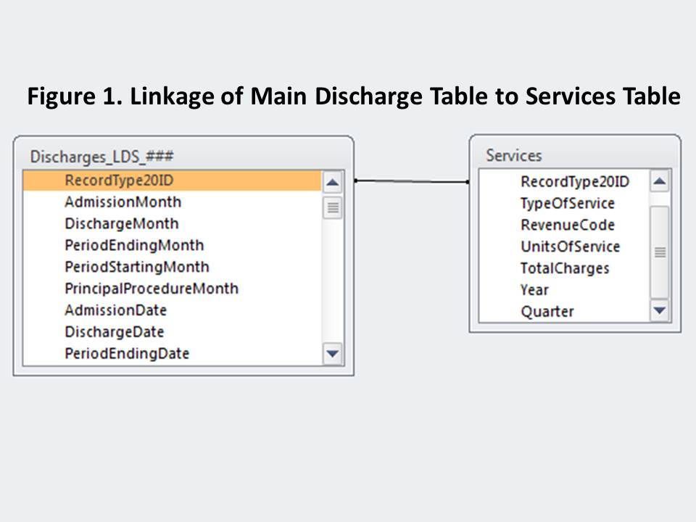

##### Linkage to Diagnoses Table containing the following fields (See Figure 2):

**RecordType20ID** – linkage ID to Discharge table

**Indicator** (A=Admitting Diagnosis, D = Discharge Diagnosis, S =Associated Diagnosis)

Associated Indicator (numbered 0 through 104, the Admitting and Discharge Diagnoses have an associated indicator of ‘0’ and the associated diagnosis are numbered 1, 2, 3, 4. through 104 which is the maximum number of diagnoses submitted in FY2015

DiagnosisCode (International Classification of Diseases, Ninth Revision, Clinical Modification (ICD-9-CM),

ConditionPresent (Y=Yes, N = No, U = Unknown, W = Clinically undetermined, 1 = Not Applicable and blanks)

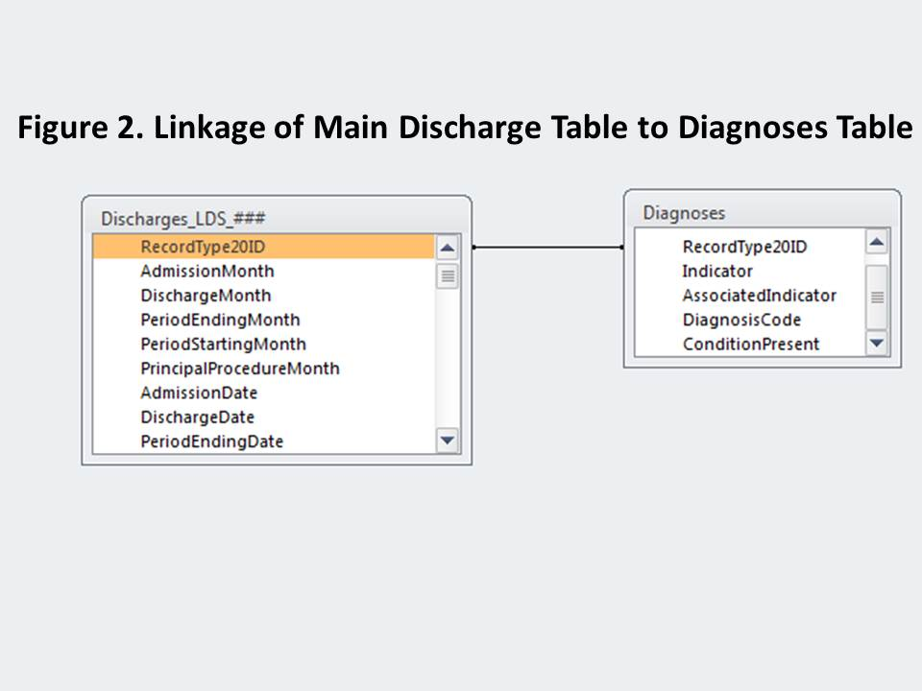

##### Linkage to Procedures Table containing the following fields (See Figure 3):

**RecordType20ID** – linkage ID to Discharge table

**Indicator (All procedure codes have an indicator of S for Associated Procedures**

Associated Indicator (numbered 1 through 67 which is the maximum number of procedures submitted in FY2015 ProcedureCode (International Classification of Diseases, Ninth Revision, Clinical Modification (ICD-9-CM),

ProcedureDate (Date procedure was performed)

PreOperativeDays (Days between admission date and date procedure was performed)

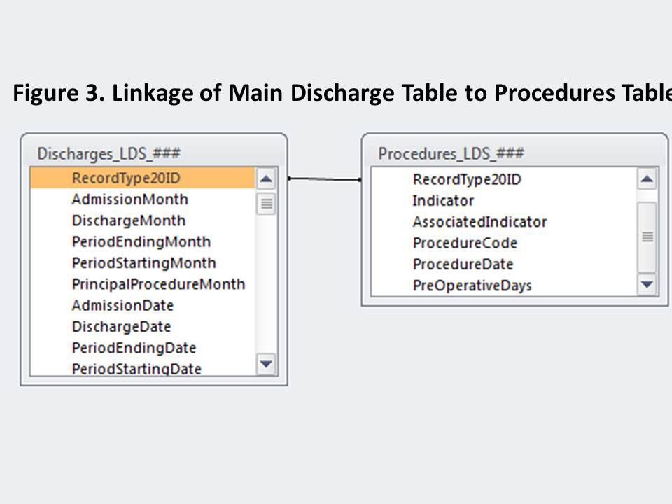

Any additional questions can be addressed by contacting CHIA at [CaseMix.data@state.ma.us](mailto:CaseMix.data@state.ma.us).

**The DRG file uses the same linkage field to the main Discharge Table: Record Type 20ID.**

**Main Discharge TableDischarge_LDS_### which is linked to contains the following 67 fields.**

|  |  |  |
| --- | --- | --- |
| **RecordType20ID** | | |
| **AdmissionMonth** |  | **LengthOfStay** |
| **DischargeMonth** |  | **NewBornAge** |
| **PeriodEndingMonth** |  | **NumberOfANDs (Administratively Necessary Days)** |
| **PeriodStartingMonth** |  | **NumberOfDiagnosisCodes** |
| **PrincipalProcedureMonth** |  | **NumberOfProcedureCodes** |
| **AdmissionDate** |  | **OtherCareGiverCode** |
| **DischargeDate** |  | **OutpatntObsrvStayFlagCode** |
| **PeriodEndingDate** |  | **PatientStatus** |
| **PeriodStartingDate** |  | **PayerCode1** |
| **PrincipalProcedureDate** |  | **PayerCode2** |
| **UHIN** |  | **PeriodEndingYear** |
| **UHIN_SequenceNo** |  | **PeriodStartingYear** |
| **AdmissionDayOfWeek** |  | **PermanentPatientStateLDS** |
| **AdmissionSourceCode1** |  | **PermanentPatientZIP3CodeLDS** |
| **AdmissionSourceCode2** |  | **PrimaryPayerType** |
| **AdmissionType** |  | **PrimaryConditionPresent** |
| **AdmissionYear** |  | **PrimaryDiagnosisCode** |
| **AgeLDS** |  | **PrincipalPreoperativeDays** |
| **Birthweight** |  | **PrincipalProcedureCode** |
| **ConditionPresentECode** |  | **Quarter** |
| **DaysBetweenStays** |  | **SecondaryPayerType** |
| **DischargeDayOfWeek** |  | **SexLDS** |
| **DischargePassed** |  | **SpecialConditionIndicator** |
| **DischargeYear** |  | **PermanentPatientCountryLDS** |
| **Ecode** |  | **SubmissionControlID** |
| **EDFlagCode** |  | **SubmissionPassedFlag** |
| **HispanicIndicator** |  | **TemporaryPatientStateLDS** |
| **HomelessIndicator** |  | **TemporaryPatientZip3CodeLDS** |
| **IdOrgFiler** |  | **TotalChargesAll** |
| **IdOrgHosp** |  | **TotalChargesAncillaries** |
| **IdOrgSite** |  | **TotalChargesRoutine** |
| **IdOrgTransfer** |  | **TotalChargesSpecial** |
| **LeaveOfAbsenceDays** |  | **Year** |

### Hospital Location and ORG IDs

1. HOSPITAL Location and ORG IDs

| **IdOrgSite** | **IdOrgFiler** | **IdOrgHosp** | **Org Name** | **City** | **Zip Code** |
| --- | --- | --- | --- | --- | --- |
| 1 | 1 | 1 | Anna Jaques Hospital | Newburyport | 01950 |
| 2 | 2 | 2 | Athol Memorial Hospital | Athol | 01331 |
| 3 | 116 | 345 | North Shore Medical Center - Union Campus | Lynn | 01904 |
| 4 | 4 | 4 | Baystate Medical Center | Springfield | 01199 |
| 5 | 5 | 5 | Baystate Franklin Medical Center | Greenfield | 01301 |
| 6 | 6 | 6 | Baystate Mary Lane Hospital | Ware | 01082 |
| 7 | 7 | 6309 | Berkshire Medical Center - Berkshire Campus | Pittsfield | 01201 |
| 8 | 8 | 8 | Fairview Hospital | Great Barrington | 01230 |
| 10 | 10 | 8702 | Beth Israel Deaconess Medical Center - East Campus | Boston | 02215 |
| 16 | 16 | 3107 | Boston Medical Center - Menino Pavilion Campus | Boston | 02118 |
| 22 | 22 | 22 | Brigham and Women's Hospital | Boston | 02115 |
| 25 | 25 | 25 | Signature Healthcare Brockton Hospital | Brockton | 02302 |
| 27 | 27 | 3108 | Cambridge Health Alliance - Cambridge Hospital Campus | Cambridge | 02139 |
| 39 | 39 | 39 | Cape Cod Hospital | Hyannis | 02601 |
| 40 | 40 | 40 | Falmouth Hospital | Falmouth | 02540 |
| 41 | 41 | 41 | Steward Norwood Hospital, Inc. | Norwood | 02062 |
| 42 | 42 | 42 | Steward Carney Hospital, Inc. | Dorchester | 02124 |
| 46 | 46 | 46 | Boston Children's Hospital | Boston | 02115 |
| 49 | 49 | 3110 | MetroWest Medical Center - Framingham Campus | Framingham | 01701 |
| 50 | 50 | 50 | Cooley Dickinson Hospital | Northampton | 01061 |
| 51 | 51 | 51 | Dana-Farber Cancer Institute | Boston | 02115 |
| 53 | 53 | 53 | Beth Israel Deaconess Hospital - Needham | Needham | 02492 |
| 57 | 57 | 57 | Emerson Hospital | Concord | 01742 |
| 59 | 59 | 59 | Brigham and Women's Faulkner Hospital | Boston | 02130 |
| 62 | 62 | 8701 | Steward Good Samaritan Medical Center - Brockton Campus | Brockton | 02301 |
| 66 | 66 | 3111 | Hallmark Health - Lawrence Memorial Hospital Campus | Medford | 02155 |
| 68 | 68 | 68 | Harrington Memorial Hospital | Southbridge | 01550 |
| 73 | 73 | 73 | Heywood Hospital | Gardner | 01440 |
| 75 | 75 | 75 | Steward Holy Family Hospital, Inc. | Methuen | 01844 |
| 77 | 77 | 77 | Holyoke Medical Center | Holyoke | 01040 |
| 79 | 79 | 79 | Beth Israel Deaconess Hospital - Plymouth | Plymouth | 02360 |
| 81 | 81 | 6546 | Lahey Hospital & Medical Center, Burlington | Burlington | 01805 |
| 83 | 83 | 83 | Lawrence General Hospital | Lawrence | 01842 |
| 85 | 85 | 85 | Lowell General Hospital | Lowell | 01854 |
| 88 | 88 | 88 | Martha's Vineyard Hospital | Oak Bluffs | 02557 |
| 89 | 89 | 89 | Massachusetts Eye and Ear Infirmary | Boston | 02114 |
| 91 | 91 | 91 | Massachusetts General Hospital | Boston | 02114 |
| 97 | 97 | 97 | Milford Regional Medical Center | Milford | 01757 |
| 98 | 98 | 98 | Beth Israel Deaconess Hospital - Milton | Milton | 02186 |
| 99 | 99 | 99 | Morton Hospital, A Steward Family Hospital, Inc. | Taunton | 02780 |
| 100 | 100 | 100 | Mount Auburn Hospital | Cambridge | 02138 |
| 101 | 101 | 101 | Nantucket Cottage Hospital | Nantucket | 02554 |
| 103 | 103 | 103 | New England Baptist Hospital | Boston | 02120 |
| 104 | 104 | 104 | Tufts Medical Center | Boston | 02111 |
| 105 | 105 | 105 | Newton-Wellesley Hospital | Newton | 02462 |
| 106 | 106 | 106 | Noble Hospital | Westfield | 01086 |
| 109 | 109 | 3112 | Lahey Health - Addison Gilbert Hospital | Gloucester | 01930 |
| 110 | 110 | 3112 | Lahey Health - Beverly Hospital | Beverly | 01915 |
| 112 | 112 | 112 | Quincy Medical Center, A Steward Family Hospital, Inc. | Quincy | 02169 |
| 114 | 114 | 114 | Steward Saint Anne's Hospital, Inc. | Fall River | 02721 |
| 115 | 115 | 85 | Lowell General Hospital Saints Campus | Lowell | 01852 |
| 116 | 116 | 345 | North Shore Medical Center - Salem Campus | Salem | 01970 |
| 118 | 118 | 6547 | Mercy Medical Center - Providence Behavioral Health Hospital Campus | Holyoke | 01040 |
| 119 | 119 | 6547 | Mercy Medical Center - Springfield Campus | Springfield | 01102 |
| 122 | 122 | 122 | South Shore Hospital | S. Weymouth | 02190 |
| 123 | 123 | 3113 | Southcoast Hospitals Group - Charlton Memorial Campus | Fall River | 02720 |
| 124 | 124 | 3113 | Southcoast Hospitals Group - St. Luke's Campus | New Bedford | 02740 |
| 126 | 126 | 126 | Steward St. Elizabeth's Medical Center | Boston | 02135 |
| 127 | 127 | 127 | Saint Vincent Hospital | Worcester | 01608 |
| 129 | 129 | 129 | Sturdy Memorial Hospital | Attleboro | 02703 |
| 130 | 131 | 3115 | UMass Memorial Medical Center - Memorial Campus | Worcester | 01605 |
| 131 | 131 | 3115 | UMass Memorial Medical Center - University Campus | Worcester | 01655 |
| 132 | 132 | 132 | Clinton Hospital - A member of the UMASS Memorial Health Center | Clinton | 01510 |
| 133 | 133 | 133 | Marlborough Hospital - A member of the UMASS Memorial Health Center | Marlborough | 01752 |
| 138 | 138 | 138 | Lahey Health - Winchester Hospital | Winchester | 01890 |
| 139 | 139 | 139 | Baystate Wing Hospital | Palmer | 01069 |
| 141 | 141 | 3111 | Hallmark Health - Melrose-Wakefield Hospital Campus | Melrose | 02176 |
| 142 | 27 | 3108 | Cambridge Health Alliance - Whidden Hospital Campus | Everett | 02149 |
| 145 | 145 | 3113 | Southcoast Hospitals Group - Tobey Hospital Campus | Wareham | 02571 |
| 457 | 49 | 3110 | MetroWest Medical Center - Leonard Morse Campus | Natick | 01760 |
| 4448 | 81 | 6546 | Lahey Medical Center, Peabody | Peabody | 01960 |
| 4460 | 4460 | 8701 | Steward Good Samaritan Medical Center - NORCAP Lodge Campus | Foxboro | 02035 |
| 6963 | 6963 | 6963 | Shriners Hospitals for Children Boston | Boston | 02114 |
| 8509 | 71 | 71 | HealthAlliance Hospital - Leominster Campus | Leominster | 01453 |
| 11466 | 11466 | 75 | Holy Family Hospital at Merrimack Valley, A Steward Family Hospital, Inc. | Haverhill | 01830 |
| 11467 | 11467 | 11467 | Nashoba Valley Medical Center, A Steward Family Hospital, Inc. | Ayer | 01432 |
| 11718 | 11718 | 11718 | Shriners Hospitals for Children Springfield | Springfield | 01104 |

Any additional questions can be addressed by contacting CHIA at [CaseMix.data@state.ma.us](mailto:CaseMix.data@state.ma.us).

**Note:** For data users trying to identify specific care sites, use IdOrgSite. However, if site number is blank, use IdOrgFiler.

1. Visit <http://www.cdc.gov/nchs/data/dvs/RaceCodeList.pdf> for additional information.
2. Available for data users as part of their data package.
3. Available for data users as part of their data package.