CENTER FOR HEALTH INFORMATION AND ANALYSIS

COST REPORT INSTRUCTIONS:
Ambulance and wheelchair Van
cost REPORT

June 2023


TABLE OF CONTENTS

PURPOSE 3
WHO MUST FILE 3
WHAT TO FILE 4
WHEN TO FILE 5
RETRIEVING AND POPULATING THE TEMPLATE 5
Download the Excel Template 5
Open and View Tabs 5
GENERAL COST REPORT INSTRUCTIONS 6
FUNCTIONAL REVENUE AND COST CENTERS 7
Tab 1: Agency Information 8
Tab 2. General Information 9
Tab 3. Mileage and Transport 9
Tab 4. Staffing Information 10
Tab 5. Vehicle Expenses 11
Tab 6. Occupancy Expenses 12
Tab 7. Revenue 13
Tab 8. Expenses 14
Tab 9. Reconciliation 18
Tab 10. Accuracy of Report 19
QUESTIONS 20

About the Ambulance and Wheelchair Van Cost Report:
- Providers are now required to submit completed cost reports through CHIA’s online submission portal, CHIA Submissions.
  - Please note, CHIA Submissions works best in Google Chrome.
  - The same login credentials previously used in INET can be used for CHIA Submissions. If you need login credentials. please follow the instructions on page 6.
- Please read all Cost Report Instructions and the CHIA Submissions User Guide thoroughly prior to beginning the cost report.
- The cost report is different than the Ambulance Revenue Report. For information on which report(s) you need to complete, reporting requirements, and instructions please see https://www.chiamass.gov/information-for-data-submitters-ambulance-and-wheelchair-van-cost-reports/.
- The Ambulance and Wheelchair Van cost report is available as an Excel template. Complete cost reports will be submitted via CHIA Submissions. Financial statements should be emailed to data@chiamass.gov, not uploaded through CHIA Submissions.
- Data must be keyed in. Please do not insert formulas or references to other spreadsheets as this may prevent the data from calculating accurately.
- All numbers must be whole numbers without decimals, except for the FTEs on Tab 4.
- If you have no amount to report for a line item, you may leave the cell blank except for Bad Debt Expense (Tab 8, Line 43), in which you must enter a “0” if you have no amount to report.
- The ‘Certification by Provider’ section, in the blue cells on Tab 10, must be filled in to save successfully.
- All submissions must be saved using the “Save Submission File” button on Tab 10, Accuracy of Report, which will only work if all errors are cleared on the tab. Submissions that are not saved by using this button cannot be read by CHIA’s system and will not successfully upload.

PURPOSE
The Center for Health Information and Analysis (CHIA), in accordance with its statutory authority under M.G.L. c. 12C, collects cost reports in furtherance of its mission to monitor the health care system in Massachusetts and to provide reliable information and meaningful analysis for those seeking to improve health care quality, affordability, access and outcomes. The data CHIA collects through the Ambulance and Wheelchair Van Cost Report is used, among other things, to support the rate-setting obligations of the Executive Office of Health and Human Services (EOHHS).Once filed with CHIA, these cost reports and financial statements become public documents and will be provided upon request to any interested party.
This document contains step-by-step instructions on how to retrieve and fill out the Excel cost report. Detailed steps for uploading and submitting a completed cost report can be found in the CHIA Submissions User Guide.

WHO MUST FILE

Non-municipal providers that earned more than $100,000 from MassHealth for services provided in FY2022 are required to file the cost report.

Providers that earned less than $100,000 from MassHealth in FY2022 and municipal providers are exempt from filing the cost report.

PLEASE NOTE
The Ambulance and Wheelchair Van cost report filing will NOT be considered complete until all relevant financial data and all additional documentation requested by CHIA staff has been provided to the satisfaction of CHIA staff.

Providers that fail to file required data with CHIA will be subject to penalties in accordance with CHIA regulation, 957 CMR 6.00, and EOHHS regulation, 101 CMR 327.00.
Specifically, CHIA may:
- Petition the Superior Court to issue an order directing governmental units to withhold payments to the agency if the agency has withheld information without a justifiable cause;
- Refer the delinquent agency to EOHHS, in which case EOHHS may impose penalties including:
  - A penalty in the amount of up to 15% of the delinquent agency’s payments;
  - A removal of the delinquent agency from the list of eligible agencies;
  - A fine, $500.00, on an agency that knowingly fails to file or that knowingly files falsified data
  - Any other penalty authorized by M.G.L. c 118E or applicable regulations.

WHAT TO FILE
- Cost Report. Agencies must file the cost report annually with CHIA for the fiscal year that ended in the year prior to the filing date. The report is available to download on CHIA’s website.

The reporting period shall be consistent with financial statements. The cost report shall be completed on the basis of the total program costs.

- Financial Statements. Agencies must submit copies of financial statements and other external documentation supporting the accuracy of the data reported on the cost report.

Agencies must file one of the following forms of acceptable documentation (in descending order of preference):
- Audited, reviewed, or compiled financial statements prepared by a Certified Public Accountant (CPA), preferably completed using generally accepted accounting principles (GAAP);
- For unaudited financial statements, a certification from a CPA attesting to the accuracy and validity of the data reported on the cost report is recommended. A certification form can be found on the CHIA website. The CPA must not be a related party to the principal owners or partners of the agency;
- Copies of tax returns filed with the Internal Revenue Service for the reporting year;
- Unaudited financial statements for the reporting year.

Email financial statement documents to data@chiamass.gov.
Label all PDF files with the Ambulance provider’s name and document type. For example, financial statements can be labeled as AgencyName_AmbFS22.pdf.

WHEN TO FILE
All ambulance and wheelchair van providers have the same due date. Providers must file the Ambulance and Wheelchair Van cost report and financial statements no later than Thursday August 31, 2023.

NOTE: If you would like to be added to CHIA’s email list to receive cost report alerts, including deployment and due dates, please request that your email address be added by emailing CostReports.Pricing@chiamass.gov.

Extensions
Providers may request a filing extension. The extension request must be submitted via email to data@chiamass.gov. The request must demonstrate a good cause or circumstances for the filing extension.

RETRIEVING AND POPULATING THE TEMPLATE

Download the Excel Template
All ambulance and wheelchair van providers can download the cost report template by visiting the following URL: https://www.chiamass.gov/information-for-data-submitters-ambulance-and-wheelchair-van-cost-reports/

Open and View Tabs
Upon opening the template, select “Enable Editing” at the top of the screen, above the formula bar, to be able to work on the report. You must also select “Enable Content”. Failure to select Enable Content will result in an inability to successfully use the template and save.

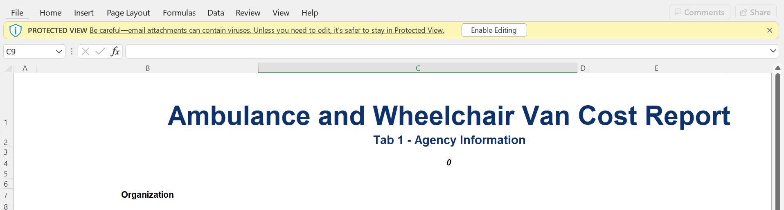

If after clicking Enable Content you receive the below error, please visit the Microsoft support page linked here to trust the template and unblock the macros. Failure to do this will result in an inability to successfully submit the cost report. Please email CostReports.Pricing@chiamass.gov if you need additional assistance.

If you do not see this error, you can proceed in filling out the cost report with no additional action required.

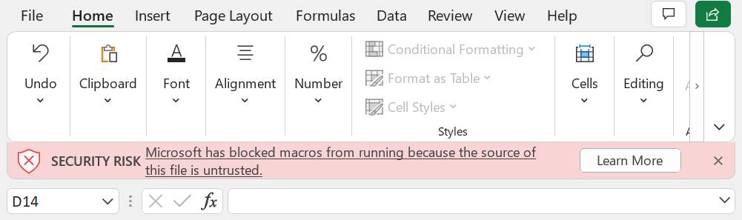

The cost report contains the following sections, to be completed by the provider and certified by an authorized individual. Providers are required to fill out all of the below tabs.

- 1. Agency Information
- 2. General Information
- 3. Mileage and Transport
- 4. Staffing Information
- 5. Vehicle Expenses
- 6. Occupancy Expenses
- 7. Revenue
- 8. Expenses
- 9. Reconciliation
- 10. Accuracy of Report

The schedules should be completed in the order listed above.

GENERAL COST REPORT INSTRUCTIONS
Please be sure to check that your provider name is in the drop down list in Tab 1 PRIOR to initiating work on the cost report.
If your provider name does not appear in the drop down list in Tab 1 of the cost report or you are a new filer with CHIA, you MUST fill out, scan, and send a User Agreement and a Business Partner Security Agreement form to CostReports.Pricing@chiamass.gov BEFORE you begin working on the cost report and attempt to submit a completed cost report.

After submitting the forms, you will receive notification and an updated cost report template that will include your provider name in the drop down. Please wait to fill out the cost report until you receive the updated template.

Agencies should use the accrual basis of accounting. All numbers must be whole numbers without decimals, except for the FTE values on Tab 4.

You may paste data into the cost report template from existing worksheets. Please paste as VALUES. If you fail to paste as values, you will not be able to save and submit successfully. Please check that pasted values are WHOLE numbers, aside from the FTE values on Tab 4 where decimals are allowed.
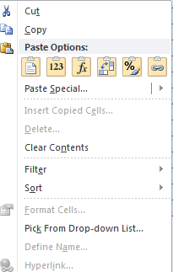
SAVE ENTERED DATA OFTEN. You may save a draft of the template at any time by using the “Save As” or “Save” options under the File menu in Excel.
You may navigate the schedules of the cost report by clicking the tabs at the bottom of the workbook.

The cost report has four different kinds of cells, designated by four different colors. The table below explains what each color means. Providers are only responsible for entering data into the blue cells.

Provider Input
Calculated
Populated/Linked
No Data to be Entered in Cell

FUNCTIONAL REVENUE AND COST CENTERS
Directly assign each expense category to the relevant cost centers whenever possible: administration, advanced life support, basic life support, wheelchair van, rotor wing, fixed wing, and other services, per your agency’s licensure level with the Massachusetts Department of Public Health. Expenses that you cannot assign directly should be allocated. A description of your allocation methodology will be requested if a field audit takes place.

Please reference the below regulations for definitions of the following cost centers:

- Advanced Life Support (ALS): 105 CMR 170.020
- Basic Life Support (BLS): 105 CMR 170.020
- Wheelchair Van: 130 CMR 407.402
- Rotor Wing: Services as defined by the Commonwealth of Massachusetts, Department of Public Health, in 105 CMR 170.465, provided through a rotary-wing aircraft (e.g., helicopter)
- Fixed Wing: Services as defined by the Commonwealth of Massachusetts, Department of Public Health, in 105 CMR 170.465, provided through a fixed-wing aircraft (e.g., airplane)
- Other Services - All revenue-generating services other than those above. Information for this category should be reported in the aggregate and need not be differentiated by program or service type.

Tab 1: Agency Information
Provider Name:
Select your provider name from the drop-down list. Please see the instructions on page 6 if your provider name is not in the dropdown. You will need to register with CHIA and receive an updated template.

Federal Employee ID Number (FEIN)
Enter your agency’s 9-digit FEIN.

MassHealth Provider ID
Enter your agency’s MassHealth Provider ID. The ID is 10 characters consisting of 9 numbers and 1 letter suffix.

National Provider Identifier (NPI)
Enter your agency’s 10-digit NPI.

Mailing Address, City, State, Zip Code
Enter your agency’s mailing address.

Main Phone Number
Enter your agency’s main phone number.

Provider Type
Select the type of provider that your agency is from the drop-down. Please ensure this is accurate as you will be required to fill out certain sections of the cost report based on your selected provider type to complete submission.

Fiscal Year Ending
Select from the drop-down the month in which your fiscal year ends.

EMS Regions
Please select “Yes” or “No” from the drop-down to indicate which regions you operate in.

Licensure Level
Select from the drop-down your company’s licensure level.

Report Contact’s Name and Title
Enter the name and title of the individual that CHIA should contact with questions about the report.

Contact’s Phone and Extension
Enter the telephone number and/or extension of the individual that CHIA should contact with questions about the report.

Email
Enter the e-mail address of the individual CHIA should contact with questions about the report.

Fax
Enter the telephone number that should be used to send a facsimile to your company.

Tab 2. General Information

Organization Type

Provider Type
Select the appropriate provider type from the drop-down box.

Profit Type
Select the appropriate profit type from the drop-down box.

Hospital Service Type
Select the appropriate hospital service type from the drop-down box. This only needs to be filled out if Provider Type is “Hospital Based”.

Level of Service
Indicate the services that are provided by your company by selecting “Yes” or “No” from the drop-down boxes. All lines must be filled out with either yes or no.

Staffing
Select the type of staffing that your company employs and enter the number of hours that your organization defines as a typical full-time work week (e.g., 40 hours).

Hours of Operation
For each type of service that your company delivers, enter the number of days per week and hours per day that these services are available.

Vehicle Information
Enter the average number of each type of vehicle that your company operated during the year as defined by the Department of Public Health in 105 CMR 170.00.

Tab 3. Mileage and Transport

A. Mileage

Lines 1-4: Total Mileage
Report the total mileage traveled by each type of transport or support vehicle.

B. Loaded Mileage

Line 6: Ambulance Mileage
Report the loaded mileage for all ambulance transports (HCPCS code A0425) during the specified accounting year.

Line 7: Wheelchair Van Mileage
Report the loaded mileage for all wheelchair van transports (HCPCS code S0215) during the specified accounting year.

Line 8: All other Loaded Miles
Report the loaded mileage for all other transports during the specified accounting year.

C. Transport Profile by Type of Service (Number of Trips)

Lines 10-22: Number of Transports

Report the number of transports made for each type of service during the specified accounting year.

For COVID-19 Wheelchair Van Transports (code A0120)
Record number of trips coded under A0120 under Line 18. A0120 is for: Nonemergency transportation: mini-bus, mountain area transports, or other transportation systems. (Each way. Used only for nonemergency wheelchair van transport for a person under investigation or known to have COVID-19.)

Tab 4. Staffing Information
This schedule reports the salaries and fulltime equivalents (FTEs) for the organization’s employees. Please Note: This schedule is for payroll employees only – costs for any subcontracted services should be reported on Tab 8, Line 10. Additionally, payroll taxes should be reported on Tab 8, Line 4, not as part of salaries on this tab.

Full-Time Equivalents (FTEs)
This column records the number of full-time equivalents for each category of employee. One full-time equivalent is the number of hours paid for a given time frame divided by the number of hours that the organization uses to define a full-time employee. For example, if 40 hours defines a full work week (as noted in the organization’s personnel policies), then 40 paid hours for a given position is 1.00 FTE and 20 hours is 0.5 FTE. To compute the FTE values for the cost report in this example, divide the total annual paid hours (including vacation, sick leave, overtime, etc.) for each category of employee in each cost center by 2,080 hours. 2,080 is the equivalent of a year’s hours, for a 40-hour work week. If your organization’s work week is other than 40 hours, the annual divisor will be the number of hours in a fulltime work week multiplied by 52 for the number of weeks in a year.

Lines 1-7: Administrative Staff
Includes the salary expenses for the services of Executive Officer(s), Fiscal Officer(s) (i.e. the professional management staff of the organization), and all other persons in the administrative area. This section also includes salary expenses for all staff that provide support to the overall functioning of the organization, including administration (e.g. receptionists, billing clerks, dispatcher, records personnel, and maintenance).

Lines 9-11: EMTs
Includes salary expenses for Emergency Medical Technicians (EMTs) who meet the function and training requirements of an EMT as required for that certification by the Department of Public Health in 105 CMR 170.00.

Line 12: Wheelchair Van Drivers-Attendants
Report the FTEs and salary expenses for employees functioning as wheelchair van drivers and attendants. If a wheelchair van driver or attendant is also an EMT or serves another function within the company, the proportion of time and wages spent as a wheelchair van driver or attendant should be reported here.

Line 13: Operations/Field Supervisors
Include the FTEs and salary expenses for employees who function as operations supervisors, shift supervisors, or field supervisors.

Line 14: Clinical Training/Medical Director
Include the FTEs and salary expenses for employees engaged in clinical training and clinical oversight of field employees (including quality assurance and improvement activities). Also include any employees who function as medical director to the company. Do not include contracted services, which will be reported on Tab 8, Line 38.

Tab 5. Vehicle Expenses
This schedule reports the expenses for vehicles used for company business. Directly assign expenses to the appropriate cost center whenever possible. If insufficient detail is maintained to permit direct assignment, report these expenses in Column 9: Expenses Not Directly Allocable. These expenses will then be allocated among the appropriate services using the number of transports from Tab 3.

Line 1: Leasing Expense
Report expenses incurred for all leased vehicles used for company business.

Line 2: Vehicle Insurance
Report expenses incurred to maintain liability, theft, and property damage insurance for vehicles used for company business.

Line 3: Interest Expense
Report interest expense incurred for loans for purchased vehicles used for company business.

Line 4: Vehicle Depreciation:
Report the total annual depreciation expense for all purchased vehicles used for company business.

Line 5: Repairs and Maintenance
Report expenses for the repair, maintenance, and warranty of vehicles. This also includes expenses and/or depreciation associated with any repair and maintenance equipment (e.g., lifts, tire machines, computerized equipment). Do not include the salary expense for in-house mechanics, which should be reported on Tab 4.

Line 6: Gas, Oil and other Vehicle Related Fluids
Report expenses for gasoline, lubricants and other fluids for all vehicles used for company business.

Line 7: Taxes
Report expenses for all taxes related to vehicles used for company business such as excise and sales taxes.

Line 8: Vehicle License and Registration
Report expenses for the Registry of Motor Vehicles and for certification and licensure of vehicles and of the ambulance service by the Office of Emergency Medical Services, Massachusetts Department of Public Health.

Line 9: Tolls
Report expenses incurred for tolls for the use of roads, bridges or tunnels for vehicles used for company business.

Lines 10-11: Other
Report all vehicle-related expenses that do not pertain to any line items listed above. Please provide a detailed description of any expenses in excess of $500.

Lines 12-16

Do not manually enter. These amounts will be automatically computed.

Lines 17-23

Do not manually enter. These amounts will be automatically transferred from Tab 3.

Tab 6. Occupancy Expenses
This schedule reports the expenses for occupancy, repair, and maintenance of the organization’s offices and other places of business. Directly assign expenses to the appropriate cost center whenever possible. If insufficient detail is maintained to permit direct assignment, report these expenses in Column 9, Expenses Not Directly Allocable.

Line 1: Rent
Report the total annual rent expense for all buildings used for company business

Line 2: Mortgage Interest
Report the interest expense incurred on the mortgages for all buildings used for company business.

Line 3: Depreciation (Building)
Report the total annual depreciation expense for all buildings used for company business.

Line 4: Depreciation (Equipment)
Report the total annual depreciation expense incurred for equipment used for company business that is not reported elsewhere.

Line 5: Repairs and Maintenance (Building)
Report expenses incurred for the general upkeep of facilities, such as plowing during the winter.

Line 6: Property Tax
Report expenses incurred for property taxes on the organization’s places of business.

Line 7: Insurance (Building and Equipment)
Report expenses incurred to maintain insurance for property damage, theft, fire, and general liability on real property and equipment, which is not otherwise reported in the report.

Line 8: Utilities
Report expenses incurred for water, electricity, and heating expenses. Specialized communications equipment expense should be reported on Tab 4, Line 13.

Line 9: Donated Space
Enter the imputed value of any building space that is donated to the organization.

Line 10: Other
Report all occupancy related expenses that do not pertain to any line items listed above. Please provide a detailed description of any expenses in excess of $500.

Line 11: Total Occupancy Expenses
Do not manually enter. This amount will be calculated automatically.

Lines 12-15: Do not manually enter. These amounts will be calculated automatically.

Lines 16-22: Square Footage
Enter the square footage occupied by each cost center.

Tab 7. Revenue
Total revenue reported on Tab 7 should equal the total revenue in the company’s financial statements. If the amounts do not match, you will be asked to explain the reason for the differences on Tab 9. Reconciliation. All revenue earned during the specified fiscal year should be listed on this schedule.

Revenue should be reported as either being Massachusetts revenue, or all other state revenue. In-state and out-of-state revenue should be broken out consistent with how the provider determines it for other purposes, including but not limited to tax purposes.

COVID-19 Revenue
Record MassHealth/Medicaid revenue from code A0120 under Medicaid revenue, Wheelchair Van (Line 3 or 11, Column 4). A0120 is for: Nonemergency transportation: mini-bus, mountain area transports, or other transportation systems. (Each way. Used only for nonemergency wheelchair van transport for a person under investigation or known to have COVID-19.)

Record MassHealth/Medicaid revenue from code A0998 under Medicaid revenue, Other Services (Line 3 or 11, Column 7). A0998 is for: Ambulance response and treatment, no transport (Used for medically necessary visits to patients to obtain and transport specimens for COVID-19 diagnostic testing).

Any revenue from COVID-19 related contracts that you entered into with EHS should be entered under “Contracts” (Line 5 or 13), and the appropriate column depending on the contract or “Other Services” (Column 7).

In both the Massachusetts and All Other States sections, the following revenue information should be entered:

Self-Pay/Private Pay
Report revenue earned from patients for services rendered that are not sponsored by any governmental or third-party entity.

Medicare
Report revenue earned from patients insured by Medicare, Railroad Medicare, or Champus/TRICARE.

Medicaid
Report revenue earned from patients insured by Medicaid, including Medicaid managed care organizations. MassHealth revenue should be entered in the Massachusetts revenue section.

Commercial Insurance
Report revenue earned from patients insured by any commercial insurance, HMO plan, and other third-party payers.

Contracts (PPS, DRG, other)
Report revenue earned from facilities (e.g., hospitals or nursing homes) for transport of their patients or residents.

Municipal Subsidy
Report revenue earned by an ambulance service provider from a city or town for the purpose of ensuring that said ambulance service shall provide services to that city or town.

All Other Payers
Report revenue earned from any sources not listed above. Include any amounts received from another ambulance service for use of your company’s services if they are not included elsewhere.

Lines 18-24: Unrestricted Grants, Gifts, and Donations
Report cash or in-kind gifts given to a provider without donor restriction as to their use. These funds are considered the property of the provider to be used as it deems appropriate.

Line 25: Total Unrestricted Grants, Gifts, and Donations
Do not manually enter. This amount will be calculated automatically.

Lines 26-32: Restricted Grants, Gifts, and Donations
Report cash or in-kind gifts that are designated by the donor for paying specified operating costs, or groups of costs, or costs of specific groups of patients. These also include funds that are designated by the donor for specific programs. These amounts should be those recognized as revenue in accordance with the provisions of FASB statement 117.

Line 33: Total Restricted Grants, Gifts, and Donations
Do not manually enter. This amount will be calculated automatically.

Lines 34-35: Non-Operating Income
Report losses other than bad debt, such as loss on investments, as a negative amount. Enter further information on Line 35.

Lines 36-37: Total Other Income and Total Revenue
Do not manually enter. These amounts will be calculated automatically.

Tab 8. Expenses

COVID-19 Expenses
Any COVID-19 related expenses should be entered in whichever line item in the Schedule fits best. For example, Medical Supplies and Equipment (Line 13) can be used for testing supplies and/or Personal Protective Equipment (PPE).

Line 1: Administrative Staff Salary/Wages
Do not manually enter. This amount will be automatically imported from Tab 4, Line 8.

Line 2: Direct Service Staff Salary/Wages
Do not manually enter. This amount will be automatically imported from Tab 4, Line 15.

Line 4: Payroll Taxes
Report employer’s share of FICA, MUICA, and FUTA (in the case of for-profit contractors) and other payroll taxes paid on behalf of the provider’s staff.

Line 5: Non-Salary Related Benefits
Report expenses for life, disability, health and medical insurance, workers compensation insurance, pension and annuity plan contributions, day care, tuition benefits and all other non-salary/wage benefits received by staff as compensation for their personal services.

Line 6: Retirement Plan
Report any retirement expense that is not reported on line 5.

Line 7: Total Employee Compensation and Related Expenses
Do not manually enter. This line will automatically calculate the sum of lines 4-6.

Line 8: Total Vehicle Expenses
Do not manually enter. This amount will be automatically imported from Tab 5, Line 16.

Line 9: Total Occupancy Expenses:
Do not manually enter. This amount will be automatically imported from Tab 6, Line 15.

Line 10: Subcontracted Staff
Report expenses for persons who are not employees on payroll. Include expenses for individuals and staffing agencies.

Line 11: Staff Training
Report expenses for formal instruction to meet professional continuing education requirements; to maintain program licensure; or to enable direct service staff to acquire and maintain appropriate levels of knowledge, skill, and proficiency for the routine performance of their assigned functions. This line item also includes any certification fees. This amount should include fees paid on behalf of employees, reimbursement of employees for fees paid by them, and the cost of bringing a trainer or consultant on-site to provide training.

The wage/salary cost for company employees who provide training, and the wages paid to company employees for attending training should not be included in this amount; such costs will be reported on Tab 4.

Line 12: Medicine/Pharmacy
Report expenses incurred to purchase medicine and pharmaceuticals for patient use.

Line 13: Medical Supplies and Equipment
Report expenses incurred to purchase medical supplies and equipment for patient use.

Line 14: Communications Equipment
Report expenses incurred for communications equipment used in the operations division of the company. Such equipment may include two-way radios, cellular telephones, pagers, and C-MED equipment. Expenses incurred in the repair or warranty of such equipment should also be reported here.

Line 15: Laundry and Uniform
Report expenses incurred to furnish uniforms, clean uniforms, launder linens, etc.

Line 16: Marketing/Development
Report expenses incurred to solicit additional business or expand your services.

Line 17: Donations
Expenses for contributions to not-for-profit agencies.

Line 18: Travel/Entertainment
Expenses for business travel and entertainment of clients or potential clients.

Line 19: Meals
Expenses for meals.

Line 20: Collection Fees
Expenses incurred for the collection of debts owed to the company. Fees of a collection agency or an attorney should be reported here.

Line 21: Public Relations
Expenses for any activity that promoted the image of the company to the general public or a targeted audience.

Line 22: Penalties and Late Charges
Expenses for late payment of amounts owed by the company.

Lines 23-24: Other
Specify any other expenses that can be directly assigned to the relevant cost centers. For example, costs incurred for medical control, medical direction and expenses incurred to subcontract the transportation portion of ALS services.

Line 25: Total Direct Allocable Expenses
Do not manually enter. This amount will calculate automatically.

Line 27: Office Supplies, Postage, Printing
Report expenses incurred for office supplies and routine office expenses.

Line 28: Insurance
Report expenses incurred for all insurance not listed on other schedules. This includes, but is not limited to, the expense of maintaining any umbrella and/or professional liability insurance for the company and its employees and directors’ and officers’ liability insurance. Do not include vehicle liability insurance which is reported on Tab 5, Line 2, building, fire, equipment, or premises liability insurance which is reported on Tab 6, Line 7, or workers compensation insurance premiums which are reported on Tab 8, Line 5.

Line 29: Interest
Report expenses incurred for any interest other than that incurred for vehicle loans, which is reported on Tab 5, Line 3, and mortgage interest which is reported on Tab 6, Line 2.

Line 30: Computer and Other Equipment
Report expenses incurred to obtain, repair, maintain, and warranty equipment including computer hardware and software, fax machines, photocopiers and telephone systems.

Line 31: Legal Fees
Report expenses incurred for the legal services of an attorney (not lobbying).

Line 32: Accounting Fees
Report expenses incurred for audit services of a CPA or other accountant.

Line 33: Accounting/Bookkeeping
Report expenses incurred for keeping routine accounting books and records.

Line 34: Payroll
Report expenses incurred to process payroll records.

Line 35: Billing Service
Report expenses incurred to generate client bills.

Line 36: Business Planning
Report expenses incurred to evaluate current operations or to formulate future growth or expansion of the business.

Line 37: Lobbying
Report expenses incurred to influence proposed legislation or other legislative or regulatory outcomes.

Line 38: Medical Director
Report expenses incurred for oversight of the paraprofessional activities of the company.

Line 39: Information Systems
Report expenses incurred for electronic systems that provide the company with operational data.

Lines 40-41: Other Professional Fees
Report expenses incurred for the services of professionals that are not reported elsewhere.

Line 42: Income Taxes
Report expenses incurred for the payment of federal, state, and local income taxes.

Line 43: Bad Debt Expense
Report expenses recognized for accounts receivable that are regarded as uncollectible following reasonable collection efforts. If you have no bad debt expense, please be sure to enter a $0 in this line to avoid an error.

Line 44: Parent Organization Expense
Report expenses recognized for any assessment, fee or allocation of expense from a parent organization. Please provide a detailed description of the parent organization’s individual expenses for any amount greater than $2,000 that was allocated to the provider. This description can be submitted as a supplemental document sent in with your financial statements, emailed to data@chiamass.gov.

Line 45: Dues/Subscriptions
Report expenses incurred for memberships in professional organizations and for media products.

Line 46: Telephone and Internet
Report expenses incurred for telephone and internet services.

Line 47: Subcontractors
Report expenses incurred to other companies for supplemental or complementary services.

Lines 48-49: Other
Specify all other categories of administrative expense. Please provide a detailed description of any expenses in excess of $500.

Lines 50-56: Do not manually enter. These amounts will be automatically calculated.

Tab 9. Reconciliation
The purpose of this tab is to show and explain any difference in total revenue and expenses as reported on the cost report compared to what is on your organization’s financial statements.

Line 1: Total Revenue in Cost Report
Do not manually enter. This line will be imported from Tab 7, Line 37.

Line 2: Total Revenue in Financial Statement
Enter the total revenue amount for the fiscal year on your financial statement that will be submitted with your cost report.

Line 3: Revenue Variance
Do not manually enter. This line will calculate the absolute value difference between Line 1 and Line 2. This will be a positive dollar value difference between the two revenue numbers.

Line 4: Total Expenses in Cost Report
Do not manually enter. This line will be imported from Tab 8, Line 54.

Line 5: Total Expenses in Financial Statement
Enter the total expense amount for the fiscal year on your financial statement that will be submitted with your cost report.

Line 6: Expense Variance
Do not manually enter. This line will calculate the absolute value difference between Line 4 and Line 5. This will be a positive dollar value difference between the two expense numbers.

Line 7: Total Variance
Do not manually enter. This line will sum together the revenue and expense variance for a total dollar value of variance.

If your variance in Line 7 is $0, no further work is required on this tab.

If the variance is greater than $0, in the chart in Lines 8-10 explain the reason for the variance. Please enter all dollar amounts as positive numbers. Use as many Item numbers as needed.

Line 8: Name
Enter the name of the item causing the variance.

Line 9: Variance (Dollar Amount)
Enter the positive dollar amount that the item is contributing to the variance.

Line 10: Explanation
Enter an explanation for why this item caused a difference between the cost report and the financial statements.

See example below:

 | Item 1
Name | Hospital Financial Statements
Variance  (Dollar Amount) | $1,500,000
Explanation | My ambulance is hospital-based. We do not have our own financials for just the ambulance part of business, so there is a difference between the two documents.

Line 11: Sum of Items Accounting for Total Variance
Do not manually enter. This line will automatically calculate the sum of Line 9, your reported reasons for variance between the cost report and financial statements.

Line 12: Is Line 11 equal to the reported differences between your cost report and financial statement?
Do not manually enter. This line checks if the number in Line 11 matches Line 7. If not, please fix the items in the chart to explain all reasons for variances between the cost report and financial statements.

Tab 10. Accuracy of Report
This schedule contains an overview of the agency’s operating revenue, expense, and profitability. The submitter must complete the provider certification by entering their electronic signature, the date, and their name in the blue cells in order to submit.

Below the filer’s acknowledgement is a list of requirements that must be met in order to successfully submit. If any of the items have an error, you must go back to that item and fix it.

When finished, click the “Save Submission” button in the bottom right of the tab. This button will only work if all of the above errors are cleared. An error is cleared when the error message is highlighted in green and reads “No Action Required.” If successful, the button automatically creates a pop-up box so you can save your template under the standard naming convention of “Org ID_Provider Name_AMBCRFY22”. Do NOT rename the file; it will not successfully upload in CHIA Submissions.

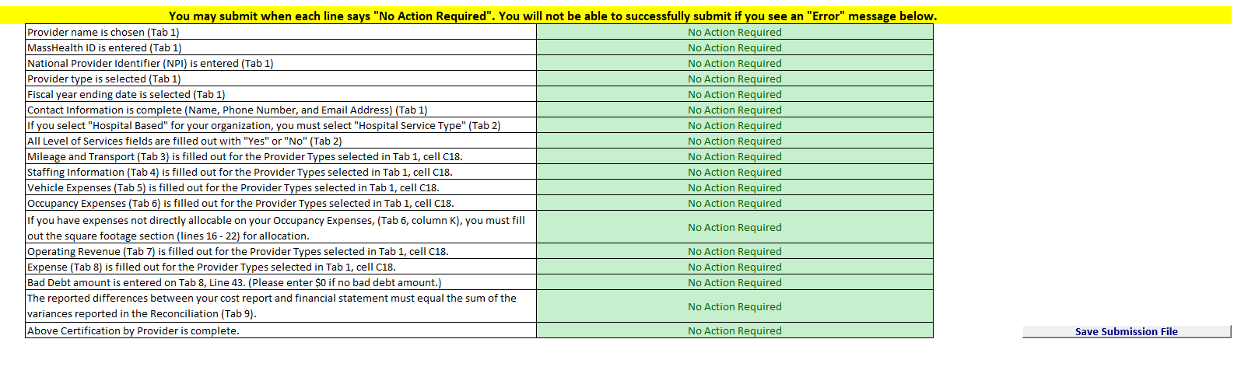

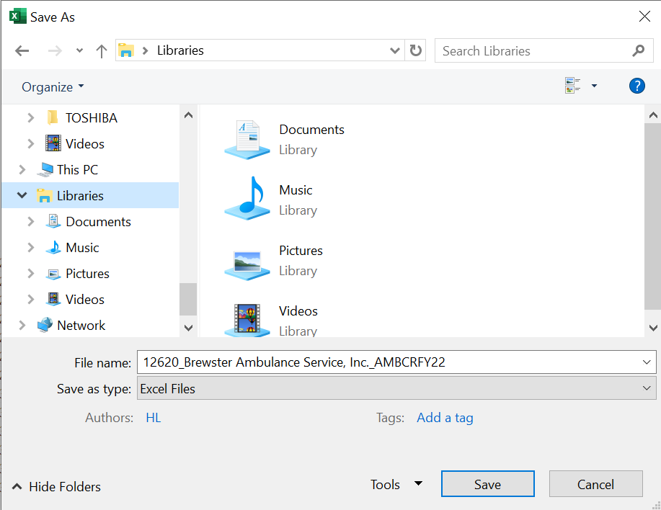

Save the file in a location you will remember when it is time to upload the cost report for submission.

You are now ready to visit the CHIA Submissions webpage to upload and submit the report by Fiscal Year.

Detailed instructions for submitting a saved cost report can be found in the CHIA Submissions User Guide.

QUESTIONS
If your agency has not registered with CHIA, you must do so to file the cost report. See page 6 for detailed steps on registering with CHIA.
If you have questions related to the CHIA Submissions portal, please email dl-data-submitter-helpdesk@chiamass.gov.
If you have any questions, please email CostReports.Pricing@chiamass.gov with the following information in the subject line of your email:
- Name of the agency with MassHealth ID #
- Name of the cost report you are asking about
- Cost report reporting year

Subject Line Example: Question on FY2022 Ambulance Cost Report – ABC agency, ID# 123456789A

