CENTER FOR HEALTH INFORMATION AND ANALYSIS

INSTRUCTIONS:
FY2022 Ambulance revenue REPORT
June 2023


TABLE OF CONTENTS

PURPOSE 3
WHO MUST FILE 3
WHAT TO FILE 4
WHEN TO FILE 4
RETRIEVING AND POPULATING THE TEMPLATE 4
Download the Excel Template 4
Open and View Tabs 5
GENERAL REVENUE REPORT INSTRUCTIONS 5
FUNCTIONAL REVENUE AND COST CENTERS 6
Organization Information 6
Report Contact Information 7
Massachusetts Ground Ambulance Revenue 7
SUBMISSION 8
QUESTIONS 8

About the New Ambulance Revenue Report (PLEASE REVIEW):
- Please read all Instructions thoroughly prior to beginning the Revenue Report.
- The Revenue Report is different than the Ambulance and Wheelchair Van Cost Report. For information on which report(s) you need to complete, reporting requirements, and instructions please see https://www.chiamass.gov/information-for-data-submitters-ambulance-and-wheelchair-van-cost-reports/.
- The FY22 Revenue Report only collects information on the organization and Massachusetts ground ambulance revenue. It does not collect expense data, staffing data, or other data that has been collected on cost reports.
- All revenue reported in the report should be Massachusetts revenue net of bad debt, charity care, and payer discounts.
- The Ambulance Revenue Report is available as an Excel template. Complete revenue reports should be emailed to data@chiamass.gov. They will not be uploaded through CHIA Submissions or INET.
- Data must be keyed in. Please do not insert formulas or references to other spreadsheets as this may prevent the data from calculating accurately.
- All numbers must be whole numbers without decimals.
- Please ensure you fill out all sections under Organization information and Report Contact Information. If you have no amount to report for a revenue line item, you may leave the cell blank.

PURPOSE
The Center for Health Information and Analysis (CHIA), in accordance with its statutory authority under M.G.L. c. 12C, collects financial information in furtherance of its mission to monitor the health care system in Massachusetts and to provide reliable information and meaningful analysis for those seeking to improve health care quality, affordability, access and outcomes. The data CHIA collects through the Ambulance Revenue Report is used, among other things, to inform policy-making obligations related to the Nonpublic Ambulance Service Reimbursement Trust Fund as outlined in 101 CMR 324.00 for the Executive Office of Health and Human Services (EOHHS). Once filed with CHIA, this information becomes public record and will be provided upon request to any interested party.

WHO MUST FILE
All ground ambulance providers who provided services in Massachusetts in FY22 must file unless they are municipal providers. The term “provider” will be used throughout these instructions to refer to all filers.

Municipal providers are exempt from filing the report, as are providers who do not provide ground ambulance services.

PLEASE NOTE
The Ambulance Revenue Report filing will NOT be considered complete until all relevant financial data requested by CHIA staff has been provided to the satisfaction of CHIA staff.

Providers that fail to file required data with CHIA will be subject to penalties in accordance with CHIA regulation, 957 CMR 6.00, and EOHHS regulation, 101 CMR 327.00.
Specifically, CHIA may:
- Petition the Superior Court to issue an order directing governmental units to withhold payments to the agency if the agency has withheld information without a justifiable cause;
- Refer the delinquent agency to EOHHS, in which case EOHHS may impose penalties including:
  - A penalty in the amount of up to 15% of the delinquent agency’s payments;
  - A removal of the delinquent agency from the list of eligible agencies;
  - A fine, $500.00, on an agency that knowingly fails to file or that knowingly files falsified data
  - Any other penalty authorized by M.G.L. c 118E or applicable regulations.

WHAT TO FILE
Revenue Report. Agencies must file the revenue report with CHIA for fiscal year 2022. The reporting period shall be consistent with the provider’s fiscal year. The report template is available to download on CHIA’s website.

Email revenue reports in Excel format to data@chiamass.gov. Name the file with the Ambulance provider’s name and document type in the naming convention: AgencyName_AmbRR22.xlsx.
No other documents are required to be included in the submission, unless requested by CHIA.

WHEN TO FILE
All ambulance providers have the same due date. Providers must file the Ambulance revenue report no later than Thursday, August 31.

NOTE: If you would like to be added to CHIA’s email list to receive cost and revenue report alerts, including deployment and due dates, please request that your email address be added by emailing CostReports.Pricing@chiamass.gov.

Extensions
Providers may request a filing extension. The extension request must be submitted via email to data@chiamass.gov. The request must demonstrate a good cause or circumstances for the filing extension.

RETRIEVING AND POPULATING THE TEMPLATE

Download the Excel Template
All ambulance providers can download the revenue report template by visiting the following URL: https://www.chiamass.gov/information-for-data-submitters-ambulance-and-wheelchair-van-cost-reports/

Open and View Tabs
Upon opening the template, select “Enable Editing” at the top of the screen, above the formula bar, to be able to work on the report. You must also select “Enable Content” if it appears. Failure to select Enable Editing or Enable Content may result in an inability to successfully use the template.

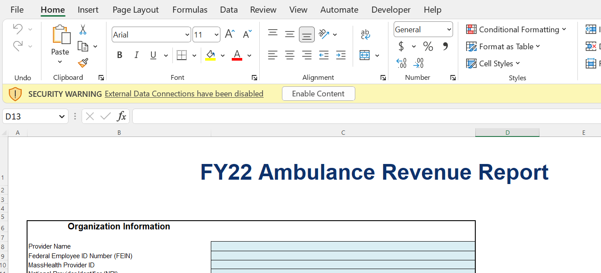

The revenue report contains the following sections, to be completed by the provider:

- Organization Information
- Report Contact Information
- Massachusetts Ground Ambulance Revenue

GENERAL REVENUE REPORT INSTRUCTIONS

Please be sure to check that your provider name is in the drop down list in Tab 1 PRIOR to initiating work on the revenue report.

If your provider name does not appear in the drop down list on the revenue report or you are a new filer with CHIA, you MUST fill out, scan, and send a User Agreement and a Business Partner Security Agreement form to CostReports.Pricing@chiamass.gov BEFORE you begin working on the revenue report and attempt to submit a completed report.

After submitting the forms, you will receive notification and an updated revenue report template that will include your provider name in the drop down. Please wait to fill out the report until you receive the updated template.

Agencies should use the accrual basis of accounting. All numbers must be whole numbers without decimals.

You may paste data into the revenue report template from existing worksheets. Please paste as VALUES. Please check that pasted values are WHOLE numbers.
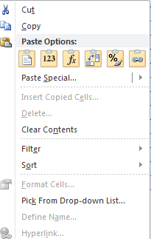
SAVE ENTERED DATA OFTEN. You may save a draft of the template at any time by using the “Save As” or “Save” options under the File menu in Excel.
The revenue report has two different kinds of cells, designated by two different colors. The table below explains what each color means. Providers are only responsible for entering data into the blue cells.

Provider Input
Calculated

FUNCTIONAL REVENUE AND COST CENTERS
Directly assign each revenue category to the relevant cost centers whenever possible: advanced life support emergency and non-emergency, and basic life support emergency and non-emergency, per your agency’s licensure level with the Massachusetts Department of Public Health. Revenue that you cannot assign directly should be allocated. A description of your allocation methodology will be requested if a field audit takes place.

Please reference the below statute or regulations for definitions of the following cost centers:

- Advanced Life Support (ALS): 105 CMR 170.020
- Basic Life Support (BLS): 105 CMR 170.020
- Emergency: M.G.L. c. 111C, s. 1

Organization Information

Please ensure you fill out this section completely.

Provider Name:
Select your provider name from the drop-down list. Please see the instructions on page 5 if your provider name is not in the dropdown. You will need to register with CHIA and receive an updated template.

Federal Employee ID Number (FEIN)
Enter your agency’s 9-digit FEIN.

MassHealth Provider ID
Enter your agency’s MassHealth Provider ID. The ID is 10 characters consisting of 9 numbers and 1 letter suffix.

National Provider Identifier (NPI)
Enter your agency’s 10-digit NPI.

Mailing Address, City, State, Zip Code
Enter your agency’s mailing address.

Main Phone Number
Enter your agency’s main phone number.

Fiscal Year Ending
Select from the drop-down the month in which your fiscal year ends.

Report Contact Information

Please ensure you fill out this section completely.

Report Contact’s Name and Title
Enter the name and title of the individual that CHIA should contact with questions about the report.

Contact’s Phone and Extension
Enter the telephone number and extension of the individual that CHIA should contact with questions about the report.

Email
Enter the e-mail address of the individual CHIA should contact with questions about the report.

Fax
Enter the telephone number that should be used to send a fax to your company. This can be left blank if your company does not use fax.

Massachusetts Ground Ambulance Revenue

All Massachusetts ground ambulance revenue should be reported in this section, split out by advanced life support (ALS) emergency and non-emergency, and basic life support (BLS) emergency and non-emergency revenue. All revenue should be reported net of bad debt, charity care, and payer discounts.

Massachusetts in-state revenue should be broken out consistent with how the provider determines it for other purposes, including but not limited to tax purposes.

Line items can be left blank if your company did not collect that type of revenue in the provider’s fiscal year.

The following revenue information should be entered and reported under one of the cost centers:

Self-Pay/Private Pay
Report revenue earned from patients for services rendered that are not sponsored by any governmental or third-party entity.

Medicare
Report revenue earned from patients insured by Medicare, Railroad Medicare, or Champus/TRICARE.

Medicaid
Report revenue earned from patients insured by Medicaid, including Medicaid managed care organizations.

Commercial Insurance
Report revenue earned from patients insured by any commercial insurance, HMO plan, and other third-party payers.

Contracts (PPS, DRG, other)
Report revenue earned from facilities (e.g., hospitals or nursing homes) for transport of their patients or residents.

Municipal Subsidy
Report revenue earned by an ambulance service provider from a city or town for the purpose of ensuring that said ambulance service shall provide services to that city or town.

All Other Payers
Report revenue earned from any sources not listed above. Include any amounts received from another ambulance service for use of your company’s services if they are not included elsewhere.

Line 36: Total Massachusetts Operating Revenue
Do not manually enter. These amounts will be calculated automatically.

SUBMISSION
Email revenue reports in Excel format to data@chiamass.gov. Name the file with the Ambulance provider’s name and document type in the naming convention: AgencyName_AmbRR22.xlsx.

No other documents are required to be included in the submission, unless requested by CHIA.

QUESTIONS
If your agency has not registered with CHIA, you must do so to file the revenue report. See page 6 for detailed steps on registering with CHIA.
If you have any questions, please email CostReports.Pricing@chiamass.gov with the following information in the subject line of your email:
- Name of the agency with MassHealth ID #
- Name of the report you are asking about
- Reporting year

Subject Line Example: Question on FY2022 Ambulance Revenue Report – ABC agency, ID# 123456789A

