Massachusetts All-Payer Claims Database:
Technical Assistance Group (TAG)
January 14, 2014
AGENDA
- IT Update
- Field Edit Report
- Version 3 Update/Questions
- Claims Versioning
IT UPDATE
FIELD EDIT REPORT
Percent Passed Calculation
- ME116 is required when ME118 = 1
- PR007 is required when PR006 = 0
PRESENT ON ADMISSION
MC154 - 178 | Present on Admission (POA) – 1 through 24
- Code Based Exemptions
- Provider Based Exemptions
- Utilize ‘ 1’ to Signify Exempt
- Utilize Variance Rationale to Denote High Level of Exempt Usage
FLAG INDICATOR FIELDS

- Expect 100% compliance on Flag Indicator fields
- Expect high usage of Unknown/Other/Not Applicable will be explained in the Variance Rationale column
Example:
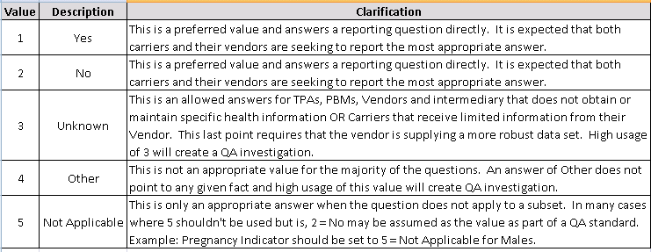

- FLAG FIELDS
PV047 | Uses Electronic Health Records
PV049 | Accepting New Patients
PV050 | Offers e-Visits

- END DATES
PROCEDURE CODE
- Outpatient Facility Revenue Code Exception
- Examples:
  - 0250 Pharmacy – General
  - 0270-0273 Medical/Surgical Supplies
  - 0370-0372 Anesthesia…etc
TOOTH NUMBER
Leading zeros will be allowed.
TME PROVIDER ID
- ME124 Attributed PCP
- ME125 Physician Group of Member’s PCP
- Required in December Filing
- Edits
- New Physician Groups
RISK ADJUSTMENT FIELDS
ME120 | Actuarial Value
ME121 | Metal Level
ME127 | Billable Member
ME128 | Benefit Plan Contract ID
ME129 | Member Benefit Plan Contract Enrollment Start Date
ME130 | Member Benefit Plan Contract Enrollment End Date

BILLABLE MEMBER
- Spouse under 21 (Final Market Reform Rules preamble (p. 13409)
- New family member (Final Market Reforms Rules -- p. 13412)
BENEFIT PLAN CONTROL TOTALS
BP005 | Monthly Claims Paid Number for the Benefit Plan | Total Number of Claims Paid | Report the total number of claim lines that correspond to the Benefit Plan Contract ID in BP001 and Monthly Net Dollars Paid in BP006. (Note that not all will be “paid” claim lines).  Use Claims Paid Date MC089 or PC063.  If no claims were paid for this BP Contract ID, report 0. Do not use a 1000 separator (commas).
BP006 | Monthly Net Dollars Paid for the Benefit Plan | Total Paid Amount | Report the monthly aggregate Total Plan Paid Amount that corresponds to the Benefit Plan Contract ID in BP001 and the Claim Type in BP004. For the medical claims, the Paid Amount is MC063 and for pharmacy claims the Paid Amount is PC036.  Calculate the total based on Paid Date (MC089 or PC063). Include fee-for-service equivalent paid amount for services that have been carved out.  Do not code decimal or round up / down to whole dollars, code zero cents (00) when applicable. EXAMPLE: 150.00 is reported as 15000; 150.70 is reported as 15070
BP007 | Total Monthly Eligible Members by Benefit Plan ID Period Date | Total Eligible Members | Number of eligible members enrolled on the 15th of the month for the Benefit Plan Contract ID reported in BP001, including billable and non-billable members.

BENEFIT PLAN CONTROL TOTALS
Control totals on the BP file should be bucketed under the plan they were covered under irrespective of which plan the member was enrolled on during the 15th of that month.
The claims and eligibility files should not “speak” to each other for the control total files:

1. BP007 - Count up the members by plan that are enrolled on the 15th
2. BP005/BP006 -Sum up the # of claims and dollars by plan (without looking at eligibility)

This way the claim dollars will line up with the claims files (eligibility might not match claims if someone enrolls after the 15th or disenrolls before the 15th).
BP007 will match up with the number of members in the ME file where the RACP Flag is YES. (ME126 = 1)

VERSION 3.0 VARIANCES
- LIAISON/MANAGER REVIEW
- VERSION 2 AS BASE NOT STANDARD
- CONDITIONAL ELEMENT VARIANCES

TEST System now accepts December files
Document Updates
CLAIMS VERSIONING
Claims Versioning Update
  - Goal: Use the highest version claim lines to produce accurate cost and utilization measures for each payer and for the Commonwealth
  - Background: CHIA has standard versioning logic, based on the APCD data submission guides:
      - Applies cleaning logic
      - Identifies duplicates, voids/back-outs, and replacements/amendments
      - Sets highest version flag
  - Since last summer, CHIA’s liaisons and QA analysts have been working closely with selected carriers to
      - Review if the CHIA standard logic apply and if any deviations
      - Examine deviations and assess potential impact. For example,
          - Consistency in submitting PCCN (MC004)
          - Former Claim Number (MC139)
          - Denied Flag (MC123)
      - Find agreeable solutions
      - Implement and validate carrier-specific versioning logic
  - Medical claims versioned for the following seven carriers (included in Release 2.0):
    - Blue Cross Blue Shield of Massachusetts
    - Boston Medical Center HealthNet Plan
    - ConnectiCare of Massachusetts, Inc.
    - Fallon Community Health
    - Harvard Pilgrim Health Care
    - Network Health
    - Tufts Health Plan
- Future releases will include versioning for pharmacy and dental claims and for other large carriers.
WRAP-UP
QUESTIONS?
TAG SCHEDULE
- February 11at 2:00 PM
- March 11 at 2:00 PM

