Massachusetts All-Payer Claims Database:
Technical Assistance Group (TAG)
February 11, 2014
Agenda
- File Transmission
- Version 3 Notes
File Transmission
- Issues persist
- IT developing Secure FTP
- SENDS+ will be required for encryption
- IT will roll out soon
Version 3 Notes
- Race/Ethnicity/Language Fields
- Diagnosis Codes/Present on Admission Indicators
- Subscriber ID/Member ID
Race/Ethnicity/Language Fields
- Self – Reported Responses Only
- Misuse of UNKNOWN
- Variance if under limited threshold
Diagnosis Codes/POA Indicators
- Fields submitted sequentially – Diagnosis 2 only present if Diagnosis 1 is present
- Present on Admission completed in agreement with Diagnosis Codes
Diagnosis Codes/POA Indicators
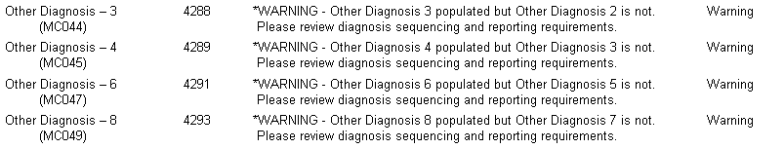

Subscriber ID/Member ID
- ME107 – Carrier Specific Unique Member ID
- ME117 – Carrier Specific Unique Subscriber ID
Expectation that ME117 = ME107 when the subscriber is the member
QUESTIONS?
Next Meetings:
March 11, 2014 at 2:00pm
April 8, 2014 at 2:00 pm
- Questions emailed to APCD Liaisons
- Questions emailed to CHIA
(CHIA-APCD@state.ma.us).
- Questions on the Data Release and Application emailed to CHIA (apcd.data@state.ma.us)

