Massachusetts All-Payer Claims Database:
Technical Assistance Group (TAG)
April 8, 2014

Agenda
- Project Update
- Qualified Health Plans (QHPs)
- ICD-10
- Version 3 Notes

Projects
- MA Health Connector Risk Adjustment
- CHIA – Total Medical Expenses (TME)
- Division of Insurance
- Group Insurance Commission

Qualified Health Plans
- Product Line of Business Code (PR004) of QH
- Guidance for Risk Adjustment fields
> RACP Indicator (ME126)
> Benefit Plan Contract ID (ME128 & BP01)
> Actuarial Value (ME120 & BP03)
> Total Monthly Premium (ME132)

ICD-10

Version 3 Notes
- ME124/ME125
- Premiums
- Compliance

ME124/ME125
ME124 – Attributed PCP
ME125 – Physician Group of Member’s PCP
- Adjusted edits to accurate subset of TME OrgIDs
- Error Summary Report to report accurate percentages
- ME125 Update Needed
- Notice to CHIA

Premiums
ME123 – Monthly Premium – subscriber amount
ME132 – Total Monthly Premium – subscriber + employer amt
- Specific guidance on Connector’s Risk Adjustment
- Do not include subsidies, cost-sharing reduction or administrative fees
- Self-Insured Accounts do not report administrative fees in lieu of total monthly premium

COMPLIANCE
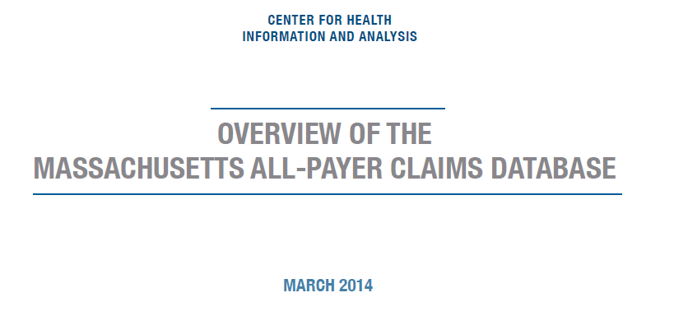

CHIA has published a white paper on the MA APCD. It is available on our website. Please feel free to take a look!

QUESTIONS?
- Questions emailed to APCD Liaisons
- Questions emailed to CHIA
(CHIA-APCD@state.ma.us).
- Questions on the Data Release and Application emailed to CHIA (apcd.data@state.ma.us)

Next Meetings
Tuesday, May 13th at 2:00 pm
Tuesday, June 10th at 2:00 pm

