Massachusetts All-Payer Claims Database:
Technical Assistance Group (TAG)
June 10, 2014
Agenda
- ACA Membership Reporting
- CHIA/DOI Data Validation
- Connector/Risk Adjustment
- V2 to V3 Profiles
- Compliance
- Retaining Copies of Data
- Questions
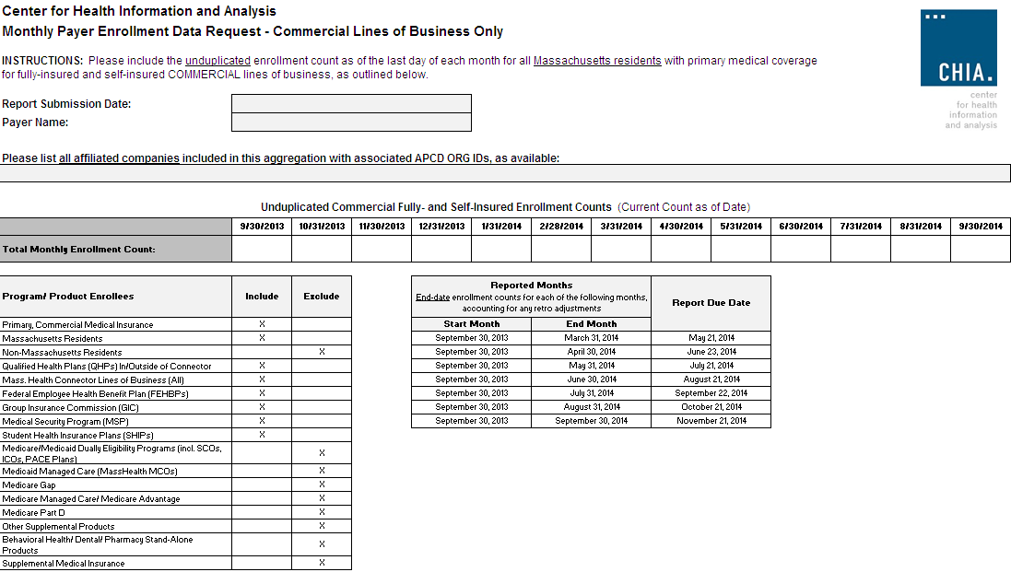
QHP Key Data Elements in MA APCD
Three fields are needed to determine whether a plan is a Qualified Health Plan, purchased inside/outside the MA Connector:
  - Product Line of Business (PR004) – (Updated to include QH for Qualified Health Plan)
  - Purchased Through MA Exchange Flag (ME045)
  - Risk Adjustment Covered Plan (ME126)

CHIA/DOI Data Validation
- DOI Quarterly HMO Membership Reports
- Compared to MA APCD Submissions
- Joint Site Visits by CHIA and DOI
- Lessons Learned

CHIA/DOI Data Validation
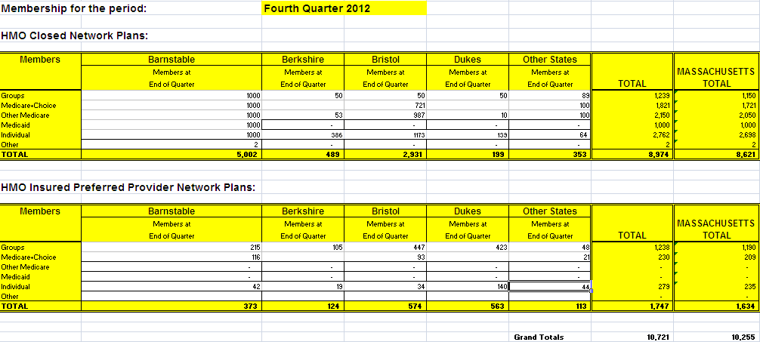

CHIA/DOI Data Validation
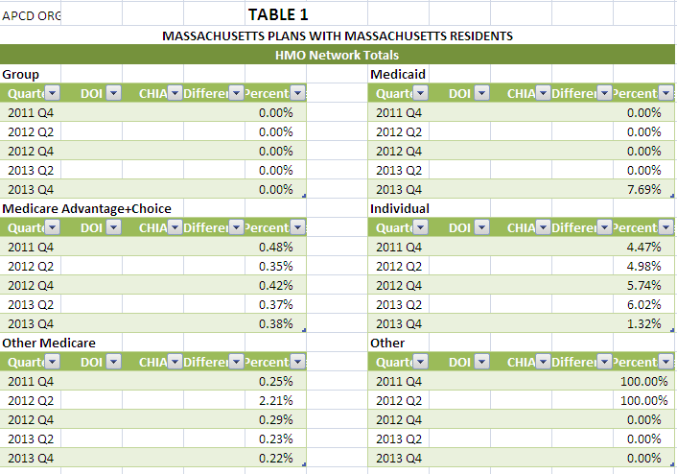

CHIA/DOI Data Validation
Lessons Learned:
- Report Timing
- Bucketing
- Membership Missing
- NAIC Codes
- Situs of Account
End Result:
Better Data! Better Reporting!
Onward Administrative Simplification!
Connector/Risk Adjustment
Next Simulation:
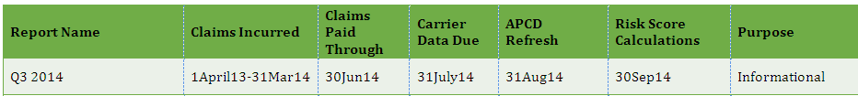
V2 to V3 Profiles
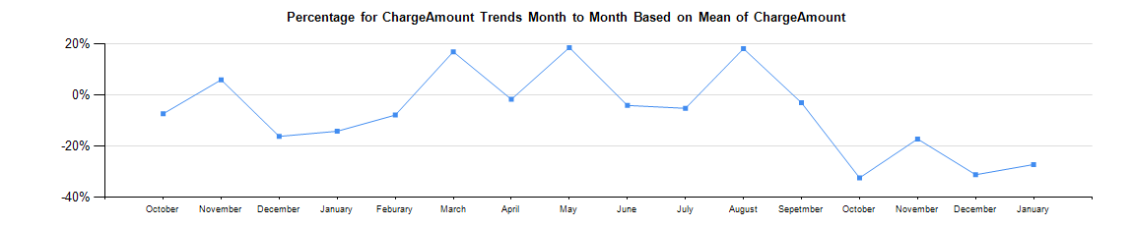

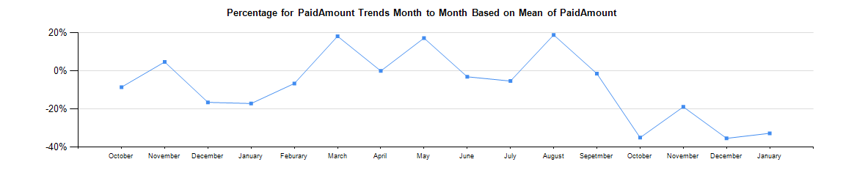

Version 3 Compliance
We are looking to have all carriers in full compliance by July with production data through June 2014.
Retaining Copies of Data
Carriers should maintain copies of the data sent to CHIA
QUESTIONS?
Next Meetings
July 8, 2014 at 2:00 pm
August 12, 2014 at 2:00 pm

