Massachusetts All-Payer Claims Database:
Technical Assistance Group (TAG)
May 14, 2013
AGENDA
- Administrative Bulletin 13-04 Published
- APCD Version 3.0 Submission Timeline
- Submission Guide and Variance Update
- Testing Update
- Field Highlights of the Month
ADMINISTRATIVE BULLETIN
- HEALTH CONNECTOR RISK ADJUSTMENT PROGRAM UPDATES
  - New fields on Member Eligibility
  - New file type
- EFFECTIVE NOVEMBER 2013 FOR SUBMISSIONS OF OCTOBER DATA
BULLETIN: ME UPDATES
ELEMENT | ELEMENT NAME | DESCRIPTION
ME120 | Actuarial Value (AV) | The actuarial value of the risk adjustment covered plan the member is enrolled in
ME121 | Metal Level | Standardized plan level in metal reference
ME126 | Risk Adjustment Covered Plan (RACP) | Member enrolled in RACP Indicator
ME127 | Billable Member | Billable Member Indicator
ME128 | Benefit Plan Contract ID | Identifier for the benefit plan the member is enrolled in as of the 15th of the month
ME129 | Member Benefit Plan Contract Enrollment Start Date | Date the member is enrolled in the benefit plan
ME130 | Member Benefit Plan Contract Enrollment EndDate | Date the member’s enrollment ends with the benefit plan
ME132 | Total Monthly Premium | Employer + Subscriber’s total contribution to monthly premium

BULLETIN: ME UPDATES
Plans not involved in Risk Adjustment will code ME126 = 2.

Element | Element Name | Description | APCD Usage and Guidelines | Condition | Category | %
ME126 | Risk Adjustment Covered Plan (RACP) | Member enrolled in RACP Indicator | Report RACP status as of the 15th of the month.  EXAMPLE: 1 = Yes, the member was enrolled in RACP as of the 15th of the month. | All | A0 | 100
 | Value | Description
 | 1 | Yes
 | 2 | No
ME120, ME121, ME127 – ME130 require no input when ME126 = 2.
BULLETIN: ME UPDATES
Element | Element Name | Description | APCD Usage and Guidelines | Condition | Category | %
ME132 | Total Monthly Premium | Employer + Subscriber’s total contribution to monthly premium | Report the total monthly premium at the subscriber level. Report 0 if no premium is charged. Do not code decimal or round up/down to whole dollars, code zero cents (00) when applicable.  EXAMPLE: 150.00 is reported as 15000; 150.70 is reported as 15070 | Required when Submitter is identified as a Risk Holder Submitter and ME060 = A, I, O, OR P –and- Member = Subscriber | A0 | 100

BULLETIN: BENEFIT PLAN CONTROL TOTAL FILE
- REQUIRED FOR RISK ADJUSTMENT PROGRAM PLANS ONLY
- EFFECTIVE NOVEMBER 2013 FOR SUBMISSIONS OF OCTOBER DATA
VERSION 3.0 SUBMISSION TIMELINE
- PRODUCTION DATA NOW DUE NOVEMBER 2013 FOR OCTOBER 2013 DATA
- THIS WILL ALLOW:
  - ADDITIONAL TIME FOR UPDATES
  - ADDITIONAL TIME FOR TESTING
  - DECREASE NEED FOR VARIANCES
  - DECREASE BURDEN ON PAYERS REQUESTED TO MEET OTHER DEADLINES AS WELL
UPDATES
- SUBMISSION GUIDE UPDATE
- VARIANCE FORM UPDATE
TESTING UPDATE
- TESTING PROCESS
- FORMAT TESTING ONLY
- FULL EDIT TESTING
FIELD HIGHLIGHTS
- Product File requirements
- Specific Field Requirements
  - Delegated Benefit OrgID
  - Risk Type
- QA Specific Fields
  - Insured Group or Policy Number (DC/MC/ME/PC006)
  - Patient Control Number
  - Payer Claim Control Number (DC/MC/PC004)
PRODUCT FILE
PRODUCT FILE IS REQUIRED FROM TPA/PBM/DBAs

How does CHIA define a Product | A Product starts as a base offering, often described by a model that it conforms to; HMO, PPO, Indemnity, etc. General accepted values appear in PR004. For non-carriers, a Product will be defined by the business and reported in a free text field to define purpose when PR004 is populated with ZZ = Other | CHIA requires that the disclosure of Pharmacy Benefit Management, Claims Processing, and Third Party Administrator organization business products, as well as Carrier-based products, to accurately assign member detail attribution for aggregate reporting and utilization.
What to report for License Type if not a ‘carrier’ | The Product file now has an element to allow for further explanation when License Type is set to PBM or Other | CHIA added two additional values so that PBMs and other non-insurance businesses can report products that they ofefr their clientele
What to report for Risk if not a ‘carrier’ | The Product file now has an element that allows for further explanation when Risk is set to Other | CHIA added additional values to the Risk Table to differentiate Risk Offerings. One of the adds is an Other that sets the requirement to populate a text element for explanation

DELEGATED BENEFIT ORGID
- DELEGATED BENEFIT ORGID: MC100, PC072, DC025
- REQUIRED FROM BOTH THE RISK HOLDER AND THE TPA/PBM/DBA
- USED FOR LINKAGE TO ENABLE COMPLETE CLAIM ANALYSIS
RISK TYPE
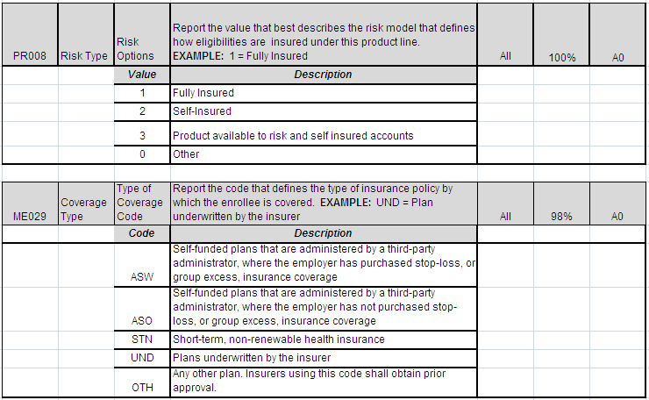
QA SPECIFIC FIELDS
ELEMENT | DATA ELEMENT NAME | LENGTH
DC006 | Insured Group or Policy Number | 30
MC006 | Insured Group or Policy Number | 30
ME006 | Insured Group or Policy Number | 30
PC006 | Insured Group or Policy Number | 30
MC068 | Patient Control Number | 20
DC004 | Payer Claim Control Number | 35
MC004 | Payer Claim Control Number | 35
PC004 | Payer Claim Control Number | 35

WRAP-UP
QUESTIONS?
TAG SCHEDULE
- JUNE 11, 2013 at 10:00 AM Please note time change
- JULY 9, 2013 at 2:00 PM

APCD Version 3.0 Schedule
Production Due November 2013
QUESTIONS
- Questions emailed to APCD Liaisons
- Questions emailed to DHCFP
(CHIA-APCD@state.ma.us).
- Questions on the Data Release and Application emailed to DHCFP (apcd.data@state.ma.us)

